DUTCH NATIONAL CHEMISTRY OLYMPIAD
2024

Assignments and Marking schemes

Preliminary round 1

Preliminary round 2

Final round


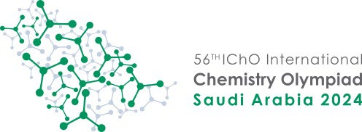





46th IChO
HANOI, VIETNAM 2014
46th IChO
HANOI, VIETNAM 2014
46th IChO
HANOI, VIETNAM 2014
Contents
Assignments preliminary round 1 3
Problem 1 Multiple choice questions 4
Problem 2 Determining manganese levels in tea leaves 14
Problem 3 Vasa 16
Assignments preliminary round 2 23
Problem 1 Multiple choice questions 25
Problem 2 Hydrogen for a fuel cell 33
Problem 3 A high-temperature superconductor 34
Problem 4 Penicillin 36
Assignments preliminary round 2 Worksheet 43
Assignments final round Theory test 47
Problem 1 NF 48
Problem 2 Dinitrogen pentoxide 49
Problem 3 Chromium 50
Problem 4 Methyl isocyanide 51
Problem 5 Electrochemical cell 52
Problem 6 Barbituric acid 53
Problem 7 Melphalan 54
Assignments final round Theory test Information sheet 57
Assignments final round Theory test Answer sheet 61
Assignments final round Practical test 63
Experiment 1 The determination of the amount of crystal water (x) in a mixture of Na₂CO₃.xH₂O and NaHCO₃ 66
Experiment 2 Kinetic study of the decomposition of tris-(oxalato)-manganate(III) ions 69
Assignments final round Practical test Answer sheets 73
Marking scheme preliminary round 1 79
Problem 1 Multiple choice questions 80
Problem 2 Determining manganese levels in tea leaves 84
Problem 3 Vasa 86
Marking scheme preliminary round 2 89
Problem 1 Multiple choice questions 90
Problem 2 Hydrogen for a fuel cell 94
Problem 3 A high-temperature superconductor 95
Problem 4 Penicillin 98
Marking scheme final round Theory test 101
Problem 1 NF 102
Problem 2 Dinitrogen pentoxide 104
Problem 3 Chromium 106
Problem 4 Methyl isocyanide 108
Problem 5 Electrochemical cell 110
Problem 6 Barbituric acid 112
Problem 7 Melphalan 114
Marking scheme final round Practical test 117
Experiment 1 The determination of the amount of crystal water (x) in a mixture of Na₂CO₃.xH₂O and NaHCO₃ 118
Experiment 2 Kinetic study of the decomposition of tris-(oxalato)-manganate(III) ions 121

NATIONAL CHEMISTRY OLYMPIAD 2024

ASSIGNMENTS PRELIMINARY ROUND 1

To be conducted from 15 until 31 January 2024



- This preliminary round consists of 25 multiple choice questions divided over 9 topics and 2 problems with a total of 8 open questions as well as an answer sheet for the multiple choice questions.
- Use the answer sheet to answer the multiple choice questions.
- Use for each problem with open questions a separate answer sheet. Don’t forget to put your name on it.
- The maximum score for this work is 77 points.
- The preliminary round lasts up to two full hours.
- Required materials: (graphic) calculator and BINAS 6th or 7th edition, ScienceData 1st edition or BINAS 5th edition, English version. Green chemistry table in the back.
- For each question the number of points you can score are given.
- Unless otherwise stated, standard conditions apply: T = 298 K and p = p₀.

- Multiple choice questions total 50 points
For each question, write your answer (letter) on the answer sheet. This answer
sheet can be found at the end of this examination booklet.
Marks: 2 points for each correct answer.

 |  | Carbon chemistry
1 |  | 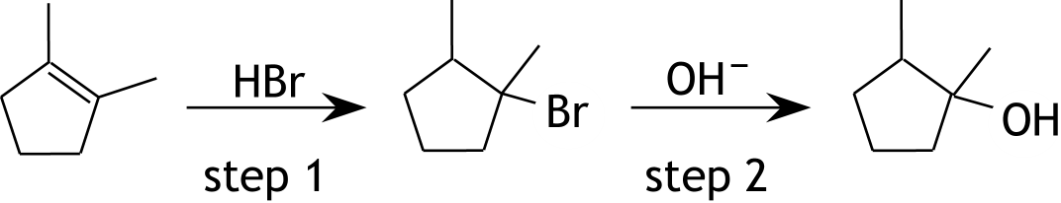  Look at the reaction scheme below.  Below are two statements about this reaction scheme:  I step 1 is an addition reaction  II step 2 is a substitution reaction  Which of the above statements is/are correct?
 | A | none
 | B | only I
 | C | only II
 | D | both
2 |  | Below is a fragment from the middle of a polymer molecule.  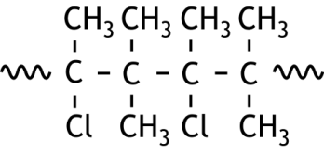  What is the name of the monomer used to form this polymer?
 | A | 2-chloro-3-methylbutane
 | B | 2-chloro-3-methylbut-2-ene
 | C | 2-chloropentane
 | D | 2-chloropent-2-ene

3 |  | A hydrocarbon X has the molecular formula C₆H₁₄. Substance X reacts with a limited amount of chlorine gas under the influence of light.  The resulting reaction mixture contains only three different monochloroalkanes with the molecular formula C₆H₁₃Cl. Two of these three monochloroalkanes have the same boiling point.  What is the structural formula of substance X?
 | A | 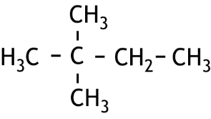
 | B | 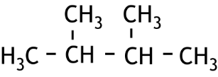
 | C | 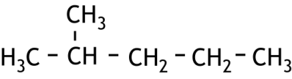
 | D | 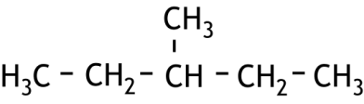
 | E | 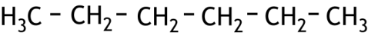

4 |  | A four-step reaction mechanism is given below. The movements of electron pairs are indicated by curly arrows.  In one of the steps one or more arrow(s) is/are drawn incorrectly.  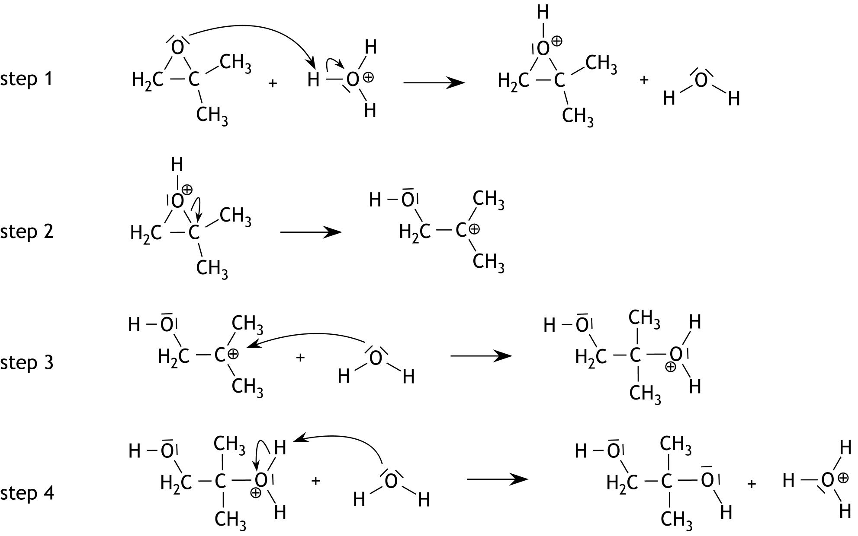  In which step is/are one or more arrow(s) drawn incorrectly ?
 | A | step 1
 | B | step 2
 | C | step 3
 | D | step 4
 |  | Reaction rate and equilibrium
5 |  | Given the homogeneous equilibrium in a HAc solution in water:  HAc + H₂O Ac— + H₃O⁺  The HAc solution is diluted with water. The new equilibrium is installed.  What applies to the number of moles of H₃O⁺ ions in the solution and what applies to the pH of the solution?  number of moles of H₃O⁺ ions pH
 | A | has become smaller has become lower
 | B | has become smaller has become higher
 | C | has become larger has become lower
 | D | has become larger has become higher

6 |  | Fenton's reagent is a solution of an iron(II) salt and hydrogen peroxide in water. Such a solution is used to convert polluting organic substances in the soil to other less harmful substances.  MTBE, with molecular formula C₅H₁₂O, is a substance that can leak into the ground when refueling gasoline. During an experiment, 1.0 mg of MTBE reacts with a large excess of Fenton's reagent. It takes 4.0 minutes to convert 98% of the MTBE.  What is the average reaction rate during these 4.0 minutes for this conversion of MTBE?
 | A | 4.6∙10^{—8} mol s^{—1}
 | B | 4.7∙10^{—8} mol s^{—1}
 | C | 1.9∙10^{—7} mol s^{—1}
 | D | 2.8∙10^{—6} mol s^{—1}
 | E | 4.1∙10^{—6} mol s^{—1}
7 |  | Ba(IO₃)₂ is a poorly soluble salt. In a saturated solution of Ba(IO₃)₂ in water the following equilibrium is established:  Ba(IO₃)₂(s) Ba²⁺(aq) + 2 IO₃—(aq)  To determine the equilibrium constant of the above equilibrium, 0.2000 grams of Ba(IO₃)₂ (M = 487.1 g mol^{—1}) is weighed out and mixed with 100 mL of water. After reaching equilibrium, the suspension is filtered and the residue is weighed. The residue was found to contain 0.1513 grams of solid Ba(IO₃)₂.  What is the value of the equilibrium constant of the above equilibrium?
 | A | 4.00∙10^{—12}
 | B | 1.00∙10^{—9}
 | C | 4.00∙10^{—9}
 | D | 1.20∙10^{—7}
 | E | 1.00∙10^{—6}
 | F | 2.00∙10^{—6}
8 |  | An experiment measures the rate of the following reaction:  Zn(s) + 2 H₃O⁺(aq) → Zn²⁺(aq) + H₂(g) + 2 H₂O(l)  The rate of this reaction is defined as the amount of H₂(g) formed per second at the start of the reaction.  In the first test, 5.0 g of zinc granules and 100 mL of 1.0 M hydrochloric acid are used. The reaction takes place at room temperature.  Which adjustment will not lead to an acceleration of the reaction?
 | A | Replace the zinc granules with 5.0 g zinc powder.
 | B | Replace the hydrochloric acid with 50 mL of 2.0 M hydrochloric acid.
 | C | Replace the hydrochloric acid with 200 mL of 1.0 M hydrochloric acid.
 | D | Heat the hydrochloric acid before adding the zinc granules.

 |  |  |  |  | Thermochemistry
 | 9 |  |  |  | When dinitrogen pentoxide decomposes, the following reactions occur consecutively:  2 N₂O₅(g) → 4 NO₂(g) + O₂(g) reaction 1  and  2 NO₂(g) → 2 NO(g) + O₂(g) reaction 2  Reaction 1 goes to completion, reaction 2 does not go to completion. Eventually a mixture of nitrogen dioxide, nitrogen monoxide and oxygen is produced. Dinitrogen pentoxide is no longer present in the reaction mixture.  The conversion of N₂O₅ to NO₂, NO and O₂ was found to have an enthalpy change of + 0.725·10⁵ J per mol N₂O₅.  What percentage of the NO₂ produced in reaction 1 was converted in reaction 2?  - the enthalpy of formation of N₂O₅ is + 0.133·10⁵ J mol^{—1};  - assume that under these conditions, the data from BINAS table 57 and ScienceData table 9.2 can be used.
 |  |  | A |  | 16.7%
 |  |  | B |  | 33.4%
 |  |  | C |  | 45.5%
 |  |  | D |  | 91.0%
 |  |  |  |  | Structures and formulas
 | 10 |  |  |  | What is the Lewis structure of diazomethane, CH₂N₂?
 |  |  | A |  | 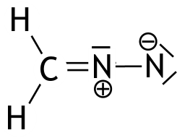
 |  |  | B |  | 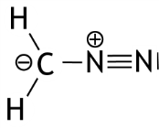
 |  |  | C |  | 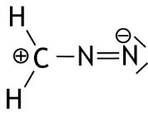
 |  |  | D |  | 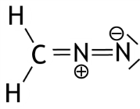
11 |  |  |  | Which of the following atoms has/have an electron domain geometry of 3?
 |  | A |  | the C atom in CH₂Cl₂
 |  | B |  | the C atom in COCl₂
 |  | C |  | the N atom in NH₃
 |  | D |  | the N atoms in N₂H₄
12 |  |  |  | Which of the following ions has the most electrons?
 |  | A |  | Cu⁺
 |  | B |  | Hg⁺
 |  | C |  | I—
 |  | D |  | Ni²⁺
 |  | E |  | Zn²⁺
 |  |  |  | pH / acid-base
13 |  |  |  | A 0.15 M solution of an unknown weak base has a pH of 12.50.  What is the K_{b} of this unknown base?
 |  | A |  | 6.7·10^{—25}
 |  | B |  | 6.7·10^{—3}
 |  | C |  | 8.4·10^{—3}
 |  | D |  | 1.2·10^{—2}
 |  | E |  | 1.0·10^{—1}
14 |  |  |  | 150 mL 0.150 M sodium hydroxide solution is mixed with 250 mL 0.100 M hydrochloric acid.  What is the pH of the final solution?
 |  | A |  | 1.30
 |  | B |  | 2.00
 |  | C |  | 2.20
 |  | D |  | 11.80
 |  | E |  | 12.00
 |  | F |  | 12.70
15 |  |  |  | Linde needs a buffer solution with a pH of 7.41 for her biology experiment with enzymes. She asks the laboratory assistant of the chemistry department for a vial with disodium hydrogen phosphate (Na₂HPO₄) and a vial with sodium dihydrogen phosphate (NaH₂PO₄).  In what mass ratio should Linde dissolve the Na₂HPO₄ and NaH₂PO₄ in demineralized water to obtain a buffer solution with a pH of 7.41?
 |  |  |  | NaH₂PO₄ |  |  | Na₂HPO₄
 |  | A |  | 1.0 g |  |  | 0.29 g
 |  | B |  | 1.0 g |  |  | 0.53 g
 |  | C |  | 1.0 g |  |  | 0.62 g
 |  | D |  | 1.0 g |  |  | 0.74 g
 |  | E |  | 1.0 g |  |  | 1.6 g
 |  | F |  | 1.0 g |  |  | 1.9 g
 |  | G |  | 1.0 g |  |  | 3.5 g

 |  | Redox and electrolysis
16 |  | Two electrolysis experiments are carried out: one with molten aluminum fluoride and one with molten lithium fluoride, using the same current. After t seconds,1.0 g of lithium is formed during the electrolysis of lithium fluoride.  After how many seconds will 1.0 g of aluminum be produced during the electrolysis of the aluminum fluoride?
 | A | 0.26t s
 | B | 0.33t s
 | C | 0.77t s
 | D | 1.3t s
17 |  | An electrochemical cell is made for electrical energy production.  Which of the following not balanced reaction equations correspond(s) to a cell that could be used for this purpose? Assume all dissolved particles have a concentration of 1.00 mol L^{—1}.  I Cr₂O₇^{2—} + Mn²⁺ + H⁺ → Cr³⁺ + MnO₄— + H₂O  II NO₃— + SO₂ → NO₂ + SO₄^{2—}
 | A | none
 | B | only I
 | C | only II
 | D | both
 |  | Analysis
18 |  | For a titration of a solution of ammonia with hydrochloric acid, the ammonia solution needs to be diluted. During the titration of 25.00 mL of this diluted ammonia solution, the equivalence point should be reached when between 12.00 mL and 25.00 mL of hydrochloric acid is added. In a rapid titration of 1.0 mL of the undiluted ammonia solution, it is found that 8.5 mL of hydrochloric acid is required.  Which of the following dilutions can be applied to ensure that the amount of the hydrochloric acid that is added lies between 12.00 mL and 25.00 mL?
 | A | 10.00 mL of the ammonia solution is diluted to 250 mL
 | B | 10.00 mL of the ammonia solution is diluted to 500 mL
 | C | 25.00 mL of the ammonia solution is diluted to 100 mL
 | D | 25.00 mL of the ammonia solution is diluted to 250 mL
 | E | 25.00 mL of the ammonia solution is diluted to 500 mL

19 |  |  |  | In an experiment to determine the molarity of sodium chloride in a solution, the Mohr method was used. In this determination, 10.00 mL of the sodium chloride solution was pipetted into a volumetric flask with a capacity of 250.00 mL. It was then filled with distilled water to the mark. From the solution in the volumetric flask, 10.00 mL was titrated with a 0.00850 M silver nitrate solution. This titration yields a white solid, silver chloride. During the determination, 14.36 mL of silver nitrate solution was required to convert all the chloride ions into silver chloride.  What was the molarity of sodium chloride in the original solution?
 |  | A |  | 6.10·10^{—3} mol L^{—1}
 |  | B |  | 1.22·10^{—2} mol L^{—1}
 |  | C |  | 1.53·10^{—1} mol L^{—1}
 |  | D |  | 3.05·10^{—1} mol L^{—1}
20 |  |  |  | Below are the structural formulas of three substances.  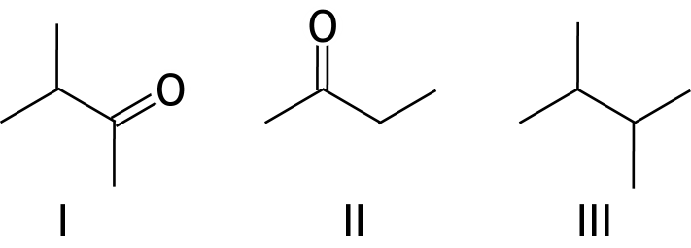  Mass spectra are generated for substances I, II and III.  In which mass spectrum/spectra does a peak appear at m/z = 43?
 |  | A |  | only in the mass spectrum of I
 |  | B |  | only in the mass spectrum of II
 |  | C |  | only in the mass spectrum of III
 |  | D |  | only in the mass spectra of I and II
 |  | E |  | only in the mass spectra of I and III
 |  | F |  | only in the mass spectra of II and III
 |  | G |  | in the mass spectra of I, II and III

21 |  | An acidic solution containing two monoprotic weak acids with different concentrations is titrated with a solution of sodium hydroxide. The image below is the titration curve of this titration.  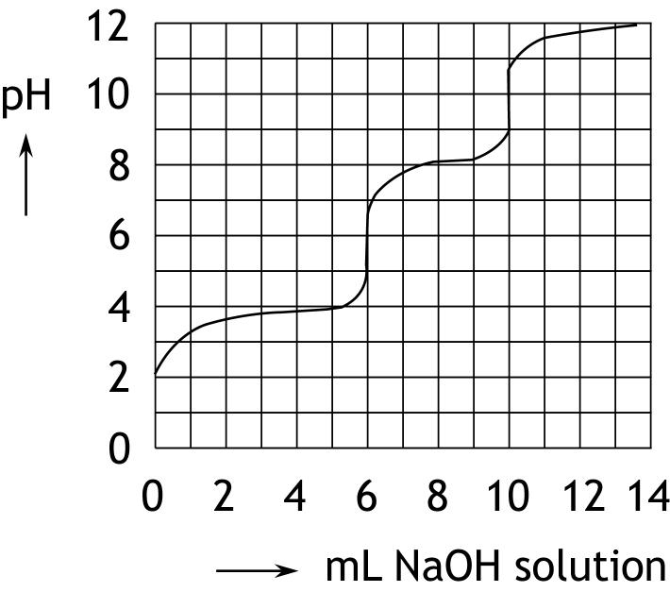  Below are two statements about this titration.  I The molarity of the weaker acid in the examined solution is higher than the molarity of the stronger acid.  II If you do not have a pH meter, you can determine the equivalence points using the indicators dimethyl yellow and thymolphtalein.  Which of these statements is/are true?
 | A | none
 | B | only I
 | C | only II
 | D | both
 |  | Chemical calculations
22 |  | Concrete corrosion, known as concrete decay, occurs when the iron present in reinforced concrete, known as reinforcement, starts to rust. Rust (Fe₂O₃) occupies more space than the iron from which it originates. Consequently, the reinforcement expands and leads to damaged concrete.  Rust is formed when iron comes into contact with water and oxygen through the following reaction:  4 Fe + 3 O₂ → 2 Fe₂O₃  The density of iron is 7.87 g cm^{—3} and the density of Fe₂O₃ is 5.25 g cm^{—3}.  What is the increase in volume (in cm³) of the reinforcement when 16.0 grams of iron is completely converted to rust according to the reaction equation above?
 | A | 0.87 cm³
 | B | 1.16 cm³
 | C | 2.03 cm³
 | D | 2.14 cm³
 | E | 2.33 cm³
 | F | 4.36 cm³

23 |  | Which of the following fuels, listed below, releases the greatest amount of CO₂ per gram of fuel during complete combustion?
 | A | CH₄
 | B | C₃H₈
 | C | C₆H₆
 | D | C₈H₁₈
 |  | Green chemistry and industry
24 |  | What happens to the atom economy and E-factor of a reaction when the percentage yield of the reaction increases?
 |  | atom economy | E-factor
 | A | decreases | decreases
 | B | decreases | stays the same
 | C | decreases | increases
 | D | stays the same | decreases
 | E | stays the same | stays the same
 | F | stays the same | increases
 | G | increases | decreases
 | H | increases | stays the same
 | I | increases | increases
25 |  | Researchers from a university in Iraq have been looking for the ideal conditions to produce zinc, having ZnO react with pure carbon at different temperatures. The researchers found that, under optimal conditions, 15 grams of powder containing 98 mass% of ZnO produced 8.0 grams of zinc.  What is the percentage yield of this zinc production?
 | A | 42%
 | B | 44%
 | C | 54%
 | D | 65%
 | E | 66%
 | F | 68%

Open questions total 27 points
- Determining manganese levels in tea leaves 11 points
Tea leaves contain small amounts of manganese; less than 0.1 percent by mass. The manganese exclusively occurs in the form of Mn²⁺ ions. The content of manganese in tea leaves can be determined using colorimetry. Because Mn²⁺ does not produce any colour in aqueous solutions, it should first be converted into permanganate (MnO₄⁻). Permanganate ions cause a purple coloration in water. For this conversion, periodate (IO₄⁻) is used, which is converted to iodate (IO₃⁻):
2 Mn²⁺ + 5 IO₄⁻ + 3 H₂O → 2 MnO₄⁻ + 5 IO₃⁻ + 6 H⁺
- Give the equation of the half-reaction for the conversion of periodate to iodate. 3
For the determination of the Mn²⁺ content of tea leaves, the periodate must be added in excess. In such a determination, 2 to 3 grams of tea leaves and roughly 0.5 g of potassium periodate are used.
- Show by calculation that adding 0.5 g of potassium periodate is more than enough to get all the Mn²⁺ in tea leaves to react. Assume that the tea leaves contain 0.1 percent Mn²⁺ by mass. 4
For a colorimetric determination of the manganese content of tea leaves, a series of solutions is first made with MnO₄⁻ contents of 0.800, 0.600, 0.400, 0.200 and 0.100 mmol L⁻¹.
For each of these solutions, the color intensity is measured using a colorimeter. These color intensities are then graphed against the MnO₄⁻ content in mmol L⁻¹. This graph is shown below.
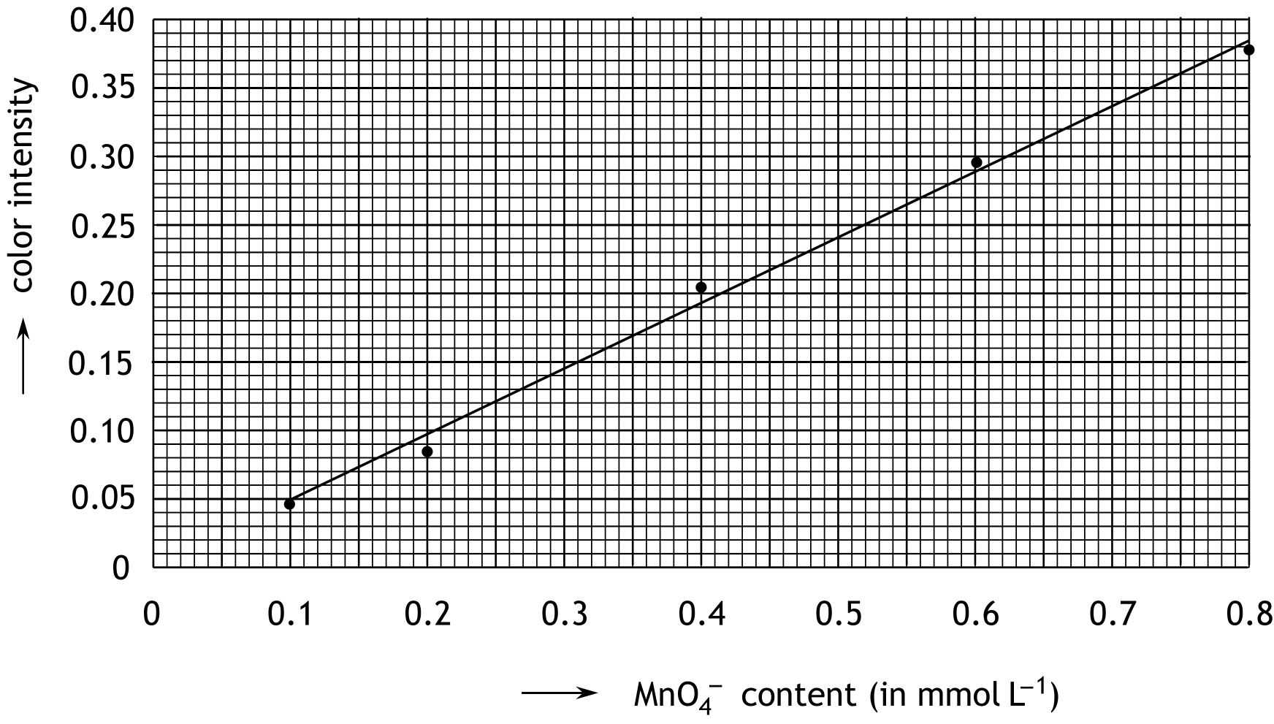

For the determination of the mass percentage of Mn²⁺ in Earl Grey tea leaves the following steps were taken:
- 2.580 g of tea leaves were heated in a porcelain crucible.
- The resulting ashes were heated with an amount of 4 M sulfuric acid solution.
- Afterwards, the mixture was filtered.
- 0.50 g potassium periodate was added to the filtrate.
- When the reaction was complete, the entire mixture was transferred into a 50 mL volumetric flask. In the flask, demineralized water was added up to the mark.
- Finally, the intensity of the purple color of this solution was measured: 0.140.
- Calculate the mass percentage of Mn²⁺ in the examined tea leaves. 4

- Vasa 16 points
Epoxyalkanes are compounds that can be thought of as being derived from alkanes by replacing per molecule two H atoms on two different C atoms with one O atom. Examples of epoxyalkanes are:
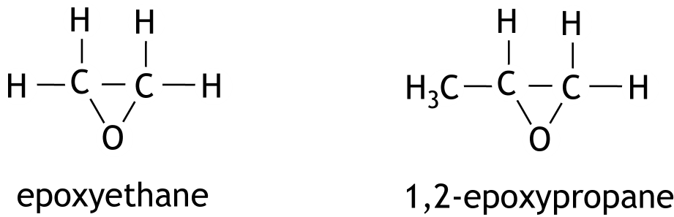

Epoxyalkanes in which the oxygen atom in the molecules is bonded to two adjacent carbon atoms can easily polymerize under the influence of sodium hydroxide. This produces polyepoxyethane from epoxyethane. This polymer is often used to preserve wooden ships that have been under water for a very long time. This happened, among other things, with the Swedish warship Vasa, which capsized in the Stockholm harbor on its maiden voyage in 1628. From April 1961, when the ship resurfaced, it was treated with polyepoxyethane for 17 years.
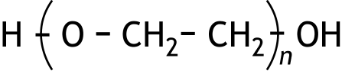
A molecule of polyepoxyethane can be represented as follows:

The value of n in this formula can vary from less than 10 to more than 100. The formation of such a polymer molecule follows a mechanism with a number of successive steps.
The first step (initiation) is the attachment of a hydroxide ion to an epoxyethane molecule:
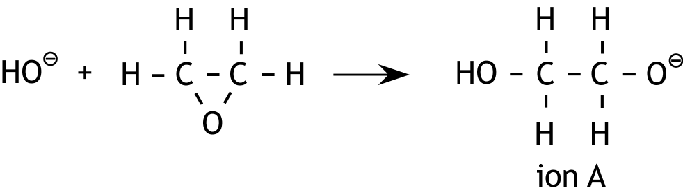

Then, starting from ion A, a number of successive propagation steps take place. A negative ion is formed again and again.
- Starting from ion A, show the first two successive propagation steps in structural formulas. 3

1,2-epoxypropane can also polymerize under the influence of sodium hydroxide. This polymerization proceeds by the same mechanism as the polymerization of epoxyethane.
- Show a part of the middle of a polymer molecule of poly-1,2-epoxypropane in structural formula. This part must be composed of three monomer units. 3

In polymerizations of epoxyalkanes, a series of successive propagation steps is terminated by a reaction with a water molecule (termination reaction). Research into the polymerization of epoxyethane under the influence of sodium hydroxide showed that, depending on the conditions under which the polymerization is carried out, different types of polyepoxyethane with different melting ranges can be obtained.
In one of the experiments in this study, an amount of polyepoxyethane with a mass of 92 grams was formed from 88 grams of epoxyethane. In this experiment there was no epoxyethane left at the end.
- Give the reaction equation for the mentioned termination reaction. Use the formula
for the end product. 3
- Calculate the average value of n in the polyepoxyethane molecules
that are formed during the experiments described above. 4
Two other experiments from this study are described below.

fabric used
 | epoxyethane  (mol) | NaOH  (mol) | H₂O  (mol)
experiment 1 | 1.0 | 0.036 | 0.33
experiment 2 | 1.0 | 0.036 | 0.10

Both experiments took place at the same temperature and pressure.
After polymerization of all epoxyethane, the polyepoxyethane was separated from the resulting reaction mixture. One of the experiments showed that polyepoxyethane was formed with a melting range of +2 ⁰C to +4 ⁰C , while in the other experiment the melting range of the resulting polyepoxyethane was +31 ⁰C to +33 ⁰C.
- Explain which of the two experiments produced polyepoxyethane with the highest melting range. 3

Green Chemistry

The twelve principles of green chemistry are:

1. Prevention Preventing waste is better than treating or cleaning up waste after it is created.
2. Atom economy Synthetic methods should try to maximize the incorporation of all materials used in the process into the final product. This means that less waste will be generated as a result.
3. Less hazardous chemical syntheses Synthetic methods should avoid using or generating substances toxic to humans and/or the environment.
4. Designing safer chemicals Chemical products should be designed to achieve their desired function while being as non-toxic as possible.
5. Safer solvents and auxiliaries Auxiliary substances should be avoided wherever possible, and as non-hazardous as possible when they must be used.
6. Design for energy efficiency Energy requirements should be minimized, and processes should be conducted at ambient temperature and pressure whenever possible.
7. Use of renewable feedstocks Whenever it is practical to do so, renewable feedstocks or raw materials are preferable to non-renewable ones.
8. Reduce derivatives Unnecessary generation of derivatives — such as the use of protecting groups — should be minimized or avoided if possible; such steps require additional reagents and may generate additional waste.
9. Catalysis Catalytic reagents that can be used in small quantities to repeat a reaction are superior to stoichiometric reagents (ones that are consumed in a reaction).
10. Design for degradation Chemical products should be designed so that they do not pollute the environment; when their function is complete, they should break down into non-harmful products.
11. Real-time analysis for pollution prevention Analytical methodologies need to be further developed to permit real-time, in-process monitoring and control before hazardous substances form.
12. Inherently safer chemistry for accident prevention Whenever possible, the substances in a process, and the forms of those substances, should be chosen to minimize risks such as explosions, fires, and accidental releases.

atom economy
percentage yield
E-factor

This exam came about with the support of the following people:

Olav Altenburg
Kees Beers
Alex Blokhuis
Johan Broens
Martin Groeneveld
Mees Hendriks
Jacob van Hengst
Dick Hennink
Emiel de Kleijn
Jasper Landman
Bob Lefeber
Marte van der Linden
Han Mertens
Joran de Ridder
Geert Schulpen
Niels Vreeswijk
Eveline Wijbenga
Amin Zadeh
Emmy Zeetsen

The final editing was done by:
Kees Beers, Dick Hennink, Marijn Jonker and Piet Mellema

The exam was translated into English by:
Eline Knol
Riëtte Pienaar
Jan Rombach
Alex Schaeffers

45th National Chemistry Olympiad 2024 preliminary round 1
Answer sheet multiple choice questions

name:

nr. | choice  letter | (score)
1
2
3
4
5
6
7
8
9
10
11
12
13
14
15
16
17
18
19
20
21
22
23
24
25
 | Total

NATIONAL CHEMISTRY OLYMPIAD 2024

ASSIGNMENTS PRELIMINARY ROUND 2
To be conducted from 19 until 22 March 2024





- This preliminary round consists of 20 multiple choice questions divided over 8 topics and 3 problems with a total of 15 open questions as well as an answer sheet for the multiple choice questions and a worksheet.
- Use the answer sheet to answer the multiple choice questions.
- Use for each problem with open questions a separate answer sheet. Don’t forget to write your name on it.
- Put your name on all pages of the worksheet.
- The maximum score for this work is 95 points.
- The preliminary round lasts a maximum of 3 clock hours.
- Required materials: (graphic) calculator and BINAS 6th or 7th edition or ScienceData 1st edition or BINAS 5th edition, English version. Green chemistry table in the back.
- For each question the number of points you can score are given.
- Unless otherwise stated, standard conditions apply: T = 298 K and p = p₀ .

This exam came about with the support of the following people:

Olav Altenburg
Alex Blokhuis
Johan Broens
Martin Groeneveld
Mees Hendriks
Jacob van Hengst
Emiel de Kleijn
Jasper Landman
Bob Lefeber
Marte van der Linden
Han Mertens
Anna Reinhold
Joran de Ridder
Geert Schulpen
Niels Vreeswijk
Eveline Wijbenga
Amin Zadeh
Emmy Zeetsen

The final editing was done by:
Kees Beers, Dick Hennink, Marijn Jonker, Piet Mellema and Pia Scheffer

The exam was translated into English by:
Lilian Buuron, Eline Knol, Riëtte Pienaar, Jan Rombach and Alex Schaeffers

Multiple choice questions total 40 points
Write your answer (letter) for each question on the answer sheet. This answer sheet can be found at the end of this examination booklet.
Marks: 2 points for each correct answer.
 |  | Carbon chemistry
1 |  | The conversion of quinone (C₆H₄O₂) to hydroquinone (C₆H₆O₂) is shown below. This conversion produces semiquinone (C₆H₅O₂) as an intermediate product. The molecule semiquinone is a radical.  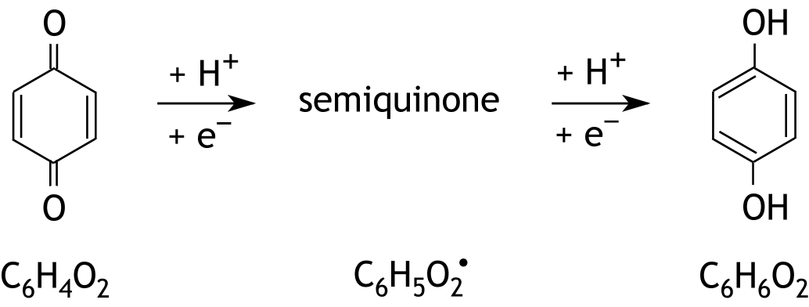  How many resonance structures, without formal charges, does a molecule of semiquinone have?
 | A | 1
 | B | 2
 | C | 3
 | D | 4
 | E | 5
 | F | 6
 | G | 7
 | H | 8
2 |  | Below three-dimensional structural formulas of two molecules are given.  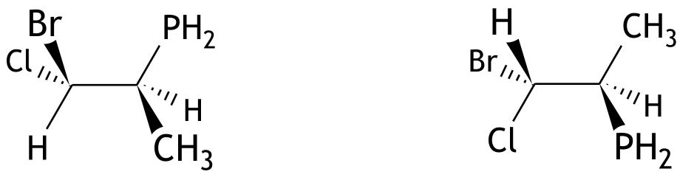  What is the relationship between these molecules?
 | A | they are diastereomers
 | B | they are enantiomers
 | C | they are identical molecules
 | D | they are structural isomers

3 |  | How many chiral centers are there in the molecule below?  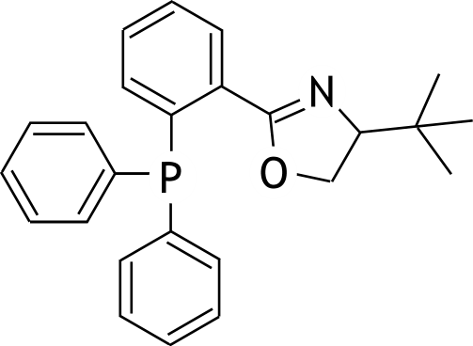
 | A | 0
 | B | 1
 | C | 2
 | D | 3
 | E | 4
 | F | 5
 |  |  | Reaction rate and equilibrium
4 |  |  | For the reaction:  O₂(g) + 4 HBr(g) → 2 H₂O(g) + 2 Br₂(g)  the following mechanism is proposed:  O₂ (g) + HBr(g) HOOBr(g) fast  HOOBr(g) + HBr(g) → 2 HOBr(g) slow  HOBr(g) + HBr(g) → H₂O(g) + Br₂(g) fast  Which rate equation fits this mechanism?
 | A |  | s = k[HBr]
 | B |  | s = k[O₂][HBr]
 | C |  | s = k[O₂][HBr]²
 | D |  | s = k[O₂][HBr]⁴

5 |  |  | Gas X dissociates when heated and the following equilibrium is reached:  X(g) Y(g) + Z(g)  An amount of X is heated to a certain temperature at a constant pressure, p. After equilibrium is reached, the partial pressure of X turns out to be equal to .  What is the value of the equilibrium constant K_{p} of the above equilibrium at this temperature?
 | A
 | B
 | C
 | D |  | 6p
 | E |  | 9p
 |  |  | Structures and formulas
6 |  |  | What are the approximate bond angles in a molecule of chloroisocyanate (Cl − N = C = O)?
 |  |  | ∠ClNC |  |  | ∠NCO
 |  | A | 109.5º |  |  | 109.5º
 |  | B | 109.5º |  |  | 120º
 |  | C | 109.5º |  |  | 180º
 |  | D | 120º |  |  | 109.5º
 |  | E | 120º |  |  | 120º
 |  | F | 120º |  |  | 180º
 |  | G | 180º |  |  | 109.5º
 |  | H | 180º |  |  | 120º
 |  | I | 180º |  |  | 180º
7 |  |  | For one electron of a Ge atom in the ground state that is in the gas phase, the set of quantum numbers 4, 1, 1, + ½ applies for n, l, m_{l} and m_{s} respectively.  Which set of the following sets of quantum numbers cannot apply for another electron of this atom?
 |  |  | n | l | m_{l} |  | m_{s}
 |  | A | 3 | 2 | 1 |  | — ½
 |  | B | 4 | 0 | 0 |  | + ½
 |  | C | 4 | 1 | 1 |  | — ½
 |  | D | 4 | 1 | 0 |  | + ½

8 |  |  | 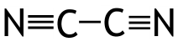  How many σ-bonds and how many π-bonds are there in a molecule of cyanogen,  ?
 |  |  | number of σ bonds |  |  | number of π bonds
 | A |  | 1 |  |  | 2
 | B |  | 1 |  |  | 4
 | C |  | 1 |  |  | 6
 | D |  | 3 |  |  | 2
 | E |  | 3 |  |  | 4
 | F |  | 5 |  |  | 2
 | G |  | 5 |  |  | 4
 |  |  |  |  | pH / acid-base
9 |  |  |  | 20 mL of a solution of substance X was pipetted into an Erlenmeyer flask. Then, a titration was performed from a burette containing a solution of substance Y. During the experiment, the pH was monitored using a pH meter. The results are displayed in the graph shown below.  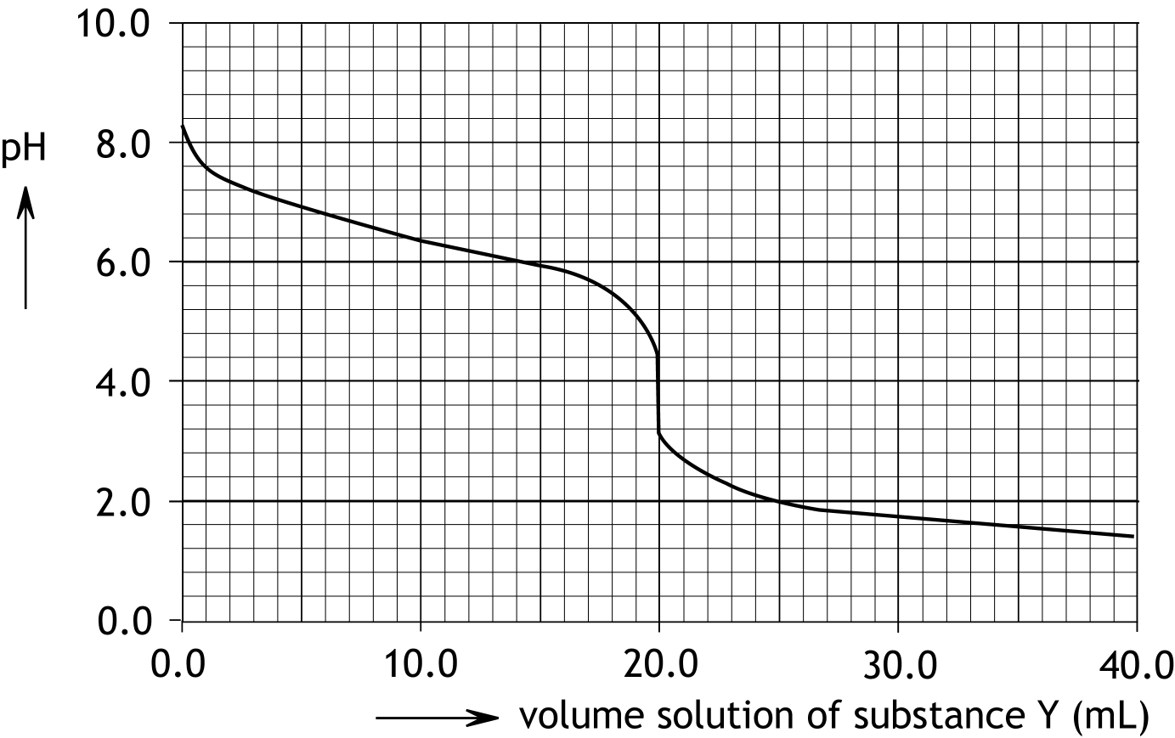  What combination of X and Y is possible?
 |  |  |  | X |  |  | Y
 |  | A |  | KOH |  |  | CH₃COOH
 |  | B |  | NaHCO₃ |  |  | HCl
 |  | C |  | CH₃COOH |  |  | NaHCO₃
 |  | D |  | KOH |  |  | HCl
 |  | E |  | HCl |  |  | NaHCO₃

10 |  |  |  | A 1.0 M NaOH solution is gradually added to 500 mL of a 0.200 M NaH₂PO₄ solution, until a buffer solution with pH = 6.90 is formed.  How many mL of the 1.0 M NaOH solution were added?
 | A |  |  | 25 mL
 | B |  |  | 33 mL
 | C |  |  | 50 mL
 | D |  |  | 67 mL
 | E |  |  | 75 mL
 | F |  |  | 100 mL
 |  |  |  |  | Redox and electrochemistry
11 |  |  |  |  |  | Which half-reactions occur in the electrolysis of a zinc sulphate solution, using two zinc electrodes?
 |  |  |  |  |  | at the negative electrode |  | at the positive electrode
 |  | A |  |  |  | 2 H₂O + 2 e— → H₂ + 2 OH— |  | 2 H₂O → O₂ + 4 H⁺ + 4 e—
 |  | B |  |  |  | 2 H₂O + 2 e— → H₂ + 2 OH— |  | Zn → Zn²⁺ + 2 e—
 |  | C |  |  |  | 2 H₂O → O₂ + 4 H⁺ + 4 e— |  | 2 H₂O + 2 e— → H₂ + 2 OH—
 |  | D |  |  |  | 2 H₂O → O₂ + 4 H⁺ + 4 e— |  | Zn²⁺ + 2 e— → Zn
 |  | E |  |  |  | Zn²⁺ + 2 e— → Zn |  | 2 H₂O → O₂ + 4 H⁺ + 4 e—
 |  | F |  |  |  | Zn²⁺ + 2 e— → Zn |  | Zn → Zn²⁺ + 2 e—
 |  | G |  |  |  | Zn → Zn²⁺ + 2 e— |  | 2 H₂O + 2 e— → H₂ + 2 OH—
 |  | H |  |  |  | Zn → Zn²⁺ + 2 e— |  | Zn²⁺ + 2 e— → Zn
12 |  |  |  |  | For which of the following half-reactions is the electrode potential dependent on the pH?  I NO₃—(aq) + 3 H⁺(aq) + 2 e— → HNO₂(aq) + H₂O(l)  II Ni(OH)₂(s) + 2 e— → Ni(s) + 2 OH—(aq)
 | A |  |  |  | for neither
 | B |  |  |  | only for I
 | C |  |  |  | only for II
 | D |  |  |  | for both I and II

13 |  |  | During an investigation of a catalyst that can potentially be used for the electrolytic conversion of carbon dioxide into methanol, an electrolysis is performed for 200 minutes with a constant current of 0.370 A. After the electrolysis, the contents of the area around the negative electrode are analyzed and found to contain  5.30·10^{—3} mol CH₃OH.  What percentage of the electric current was used for the conversion of carbon dioxide into methanol?
 | A |  | 11.5 %
 | B |  | 23.0 %
 | C |  | 46.1 %
 | D |  | 69.1 %
 | E |  | 92.1 %
 |  |  |  | Analysis
14 |  |  |  | In an acidified solution of potassium dichromate, the dichromate, Cr₂O₇^{2‒}, can be converted into chromium(III), Cr³⁺. Dichromate ions cause an orange colour in a solution and chromium(III) ions cause a green colour. Because of this colour change, an acidified potassium dichromate solution is a suitable reagent for identifying certain substances.  Aqueous solutions of the four substances listed below were made. Several drops of an acidified potassium dichromate solution were added to each solution. Only one solution turned orange.  Which solution was that?
 |  | A |  | Al₂(SO₄)₃
 |  | B |  | H₂C₂O₄
 |  | C |  | KI
 |  | D |  | SnCl₂
15 |  |  |  | The absorbance of a 3.00·10^{‒4} M potassium permanganate solution is measured at a wavelength of 525 nm using a spectrophotometer: 0.600.  To 50.0 mL of this solution, 50.0 mL of a solution of sodium sulphite is added. The following reaction occurs:  2 MnO₄‒ + 5 SO₃^{2‒} + 6 H⁺ → 2 Mn²⁺ + 5 SO₄^{2‒} + 3 H₂O  After the reaction has ended the absorbance of the resulting solution is measured, also at a wavelength of 525 nm: 0.100.  What was the molarity of the sodium sulphite solution?
 |  | A |  | 8.00·10^{‒5} mol L^{‒1}
 |  | B |  | 1.00·10^{‒4} mol L^{‒1}
 |  | C |  | 2.50·10^{‒4} mol L^{‒1}
 |  | D |  | 5.00·10^{‒4} mol L^{‒1}
 |  | E |  | 6.25·10^{‒4} mol L^{‒1}

 |  |  |  | Chemical calculations
16 |  |  |  | Which noble gas has a density of 0.826 g dm^{—3} at 900 °C and 2.00 atm?
 |  | A |  | He
 |  | B |  | Ne
 |  | C |  | Ar
 |  | D |  | Kr
 |  | E |  | Xe
17 |  |  |  | On iron ships, blocks of zinc are often applied as sacrificial metal. Zinc prevents the rusting of iron because it is a stronger reducing agent than iron, so zinc reacts and iron does not react. In this reaction, zinc is converted into zinc hydroxide. Such a block with an initial mass of 113.0 g has a mass of 140.2 g after some time of use.  What is the ratio of Zn(0) : Zn(II) in this block? Assume that the block originally consisted of pure zinc and that the formed zinc hydroxide remains on the block.
 |  | A |  | 0.0800 : 1.00
 |  | B |  | 1.08 : 1.00
 |  | C |  | 1.16 : 1.00
 |  | D |  | 2.16 : 1.00
 |  | E |  | 4.23 : 1.00
 |  | F |  | 5.32 : 1.00
 |  | G |  | 11.6 : 1.00
 |  |  | Thermochemistry and Green Chemistry
18 |  |  | Elemental copper can be produced from chalcopyrite, CuFeS₂. The reaction equation for this process is shown below:  2 CuFeS₂ + 5 O₂ + 2 SiO₂ → 2 Cu + 4 SO₂ + 2 FeSiO₃  The E-factor of this production is 6.5.  What is the percentage yield of this reaction?
 | A |  | 7.0%
 | B |  | 13%
 | C |  | 32%
 | D |  | 68%
 | E |  | 87%
 | F |  | 93%

19 |  | Below standard reaction enthalpies for two reactions of hydrogen sulfide in the gas phase are given.  H₂S(g) + 1.5 O₂(g) → SO₂(g) + H₂O(g) ∆_{r}H⁰₁ = ‒ 518.2 kJ mol^{‒1}  2 H₂S(g) + CO₂(g) → CS₂(g) + 2 H₂O(g) ∆_{r}H⁰₂ = + 67.8 kJ mol^{‒1}  What follows for the standard reaction enthalpy ∆_{r}H⁰₃ for the combustion of carbon disulfide in the gas phase: CS₂(g) + 3 O₂(g) → CO₂(g) + 2 SO₂(g)?
 | A | ‒ 450.4 kJ mol^{‒1}
 | B | ‒ 586.0 kJ mol^{‒1}
 | C | ‒ 968.6 kJ mol^{‒1}
 | D | ‒ 1104.2 kJ mol^{‒1}
20 |  | For which reaction among the ones below is Δ_{r}G⁰ closest to Δ_{r}H⁰?
 | A | 2 CO₂(g) → 2 CO(g) + O₂(g)
 | B | 2 HCl(g) → H₂(g) + Cl₂(g)
 | C | 2 H₂O(l) → 2 H₂(g) + O₂(g)
 | D | 2 NaCl(s) → 2 Na(s) + Cl₂(g)

Open questions total 55 points
- Hydrogen for a fuel cell 15 points
For sustainable energy, hydrogen seems to be a suitable energy carrier. In a fuel cell, hydrogen can be efficiently used for the production of electrical energy. However, a drawback to using hydrogen is the storage of large quantities of this gas. Therefore, research is also being conducted to investigate whether hydrogen can be stored in the form of the solid substance sodium borohydride (NaBH₄).
Sodium borohydride is not toxic and reasonably stable under normal conditions.
By hydrolyzing NaBH₄ the hydrogen gas is released again:
BH₄⁻(aq) + 2 H₂O(l) → BO₂⁻(aq) + 4 H₂(g)
This hydrolysis is a slow process at room temperature, which is why a catalyst is needed. Ruthenium (Ru) catalysts are highly active for this hydrolysis, even at room temperature. They ensure the complete conversion of NaBH₄ into H₂. Kinetic studies have shown that the catalytic hydrolysis of NaBH₄ is a zero-order reaction with respect to the concentration of BH₄⁻ and is directly proportional to the amount of Ru.
For each mole of Ru, 92 moles of H₂ are formed per minute at 298 K.
- Calculate the amount of Ru needed, in mg, for the production of 0.100 dm³ H₂ per minute from 100 mL of a 1.0 M NaBH₄ solution, at 298 K and p = p₀. 3
- Calculate how many minutes this system can produce 0.100 dm³ H₂ per minute, at 298 K and p = p₀. 4
The activation energy (E_{a}) for the catalytic hydrolysis of NaBH₄ is 42 kJ mol⁻¹.
- Calculate the temperature, in K, that is needed to produce hydrogen at the same rate (0.100 dm³ H₂ per minute) with only half the amount of catalyst available as was used at 298 K. 4
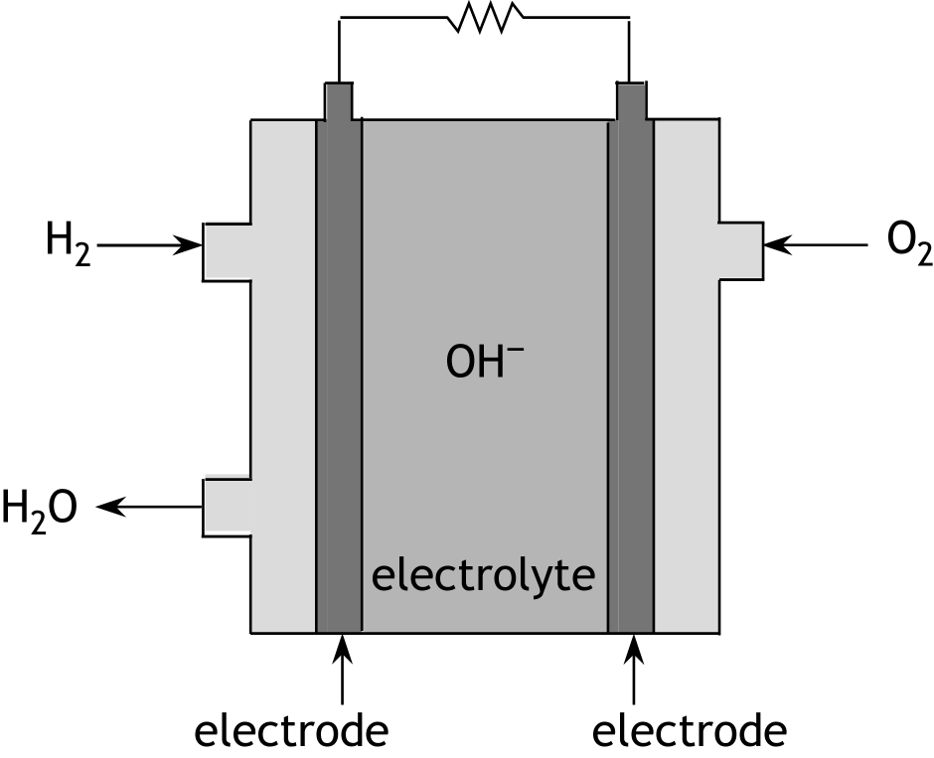
To the right of this text a schematic diagram of an alkaline hydrogen fuel cell is provided.
The essential part of the fuel cell consists of three components: two electrodes with the electrolyte in between.
The following half-reactions occur at the electrodes:

O₂ + 2 H₂O + 4 e⁻ → 4 OH⁻

H₂ + 2 OH⁻ → 2 H₂O + 2 e⁻
- Calculate the Gibbs energy for the formation of H₂O(l) in the fuel cell under standard conditions. Use ΔG⁰ = − nFΔE⁰. 4

- A high-temperature superconductor 24 points
Superconductors are materials in which an electric current can flow without encountering resistance. Superconductivity was first discovered in 1911 by the Dutch (Leiden) scientist Heike Kamerlingh Onnes during his groundbreaking work in the field of extremely low temperatures. Superconductors are useful for various applications, such as in MRI, for example. However, a drawback is that most materials only become superconducting when cooled to near the absolute zero point. It was, therefore, a breakthrough when Georg Bednorz and Alex Müller discovered a class of ceramic materials that are already superconducting when cooled with liquid nitrogen. For this discovery of high-temperature superconductors, they were awarded the Nobel Prize in Physics in 1987.
Among the best known examples of these ceramic superconductors are substances that can be represented by YBCO. These are composed of ions of yttrium (Y), barium, copper, and oxygen. The ions of yttrium (Y), barium, and copper occur in a ratio of 1 : 2 : 3. The number of oxide ions in the empirical formula of YBCO depends on the amount of oxygen that reacts during the preparation of a YBCO compound but is at most 7. The empirical formula of a YBCO compound can then be represented as YBa₂Cu₃O_{(7 − x)}.
In the preparation of YBa₂Cu₃O_{(7 − x)}, yttrium(III) carbonate, barium carbonate and copper(II) carbonate are allowed to react with each other in the presence of oxygen. Besides YBa₂Cu₃O_{(7 − x)}, only carbon dioxide is formed.
- Give the reaction equation for this preparation of YBa₂Cu₃O_{(7 − x)}. 3
During the preparation of a YBCO compound in the presence of oxygen, a portion of the Cu²⁺ ions is converted into Cu³⁺ ions. Y³⁺ and Ba²⁺ ions remain unchanged.
- Calculate the value of x in YBa₂Cu₃O_{(7 − x)} if 20% of the Cu²⁺ ions have been converted into Cu³⁺ ions. 4
To determine the value of x in a YBCO compound, an iodometric titration can be performed. Initially, the YBCO compound is allowed to react with hydrochloric acid. This results in a solution in which no Cu³⁺ is present because it has reacted with water. This reaction of Cu³⁺ with water is a redox reaction that produces, among other things, Cu²⁺ and O₂.
- Give the equations of both half-reactions and the overall reaction equation for the reaction of Cu³⁺ with water. 2
Afterwards, an excess of potassium iodide is added to the solution, leading to the following reaction:
2 Cu²⁺ + 4 I⁻ → 2 CuI + I₂
Finally, the formed iodine is titrated with a solution of sodium thiosulfate, Na₂S₂O₃. The following reaction occurs in the titration:
2 S₂O₃²⁻ + I₂ → S₄O₆²⁻ + 2 I⁻
In such a determination, 160 mg of YBCO compound was used. For the titration of the formed iodine, 21.8 mL of 0.0332 M sodium thiosulfate solution was required.
- Calculate the value of x in the examined YBCO compound. 7
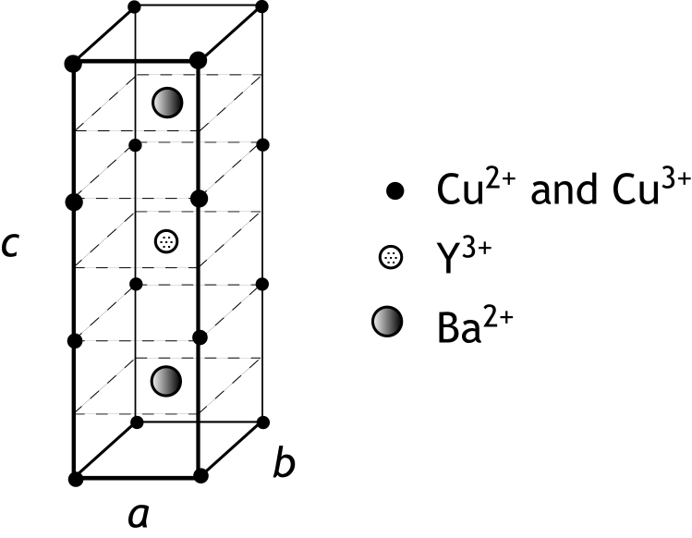
The unit cell of the crystal lattice of a YBCO compound is shown on the left.
The barium ions and the yttrium ion are located inside the cell; dashed lines represent the horizontal planes in which these ions are situated.
The copper ions are located at the corners and on the edges of the unit cell.
The oxide ions are not depicted.

To complete the drawing of the unit cell of YBa₂Cu₃O₇ (YBCO with x = 0), 20 oxide ions need to be drawn. Some of these oxide ions are located on edges, while others are situated in exterior faces of the unit cell.
- Calculate how many oxide ions are located on edges and how many are situated in exterior faces in the unit cell of YBa₂Cu₃O₇. 4
The lengths of the cell edges of the above unit cell are as follows: a = 0.382 nm, b = 0.389 nm and c = 1.168 nm.
- Calculate the density in g cm⁻³ of YBa₂Cu₃O₇. 4

- Penicillin 16 points
Penicillin is used as the collective term for the group of various types of penicillin. Penicillin has a bactericidal effect and is a commonly used antibiotic to combat infectious diseases.
Below is a schematic representation of a penicillin molecule.
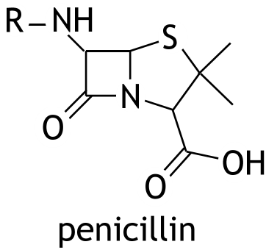

The molecules of the various types of penicillin are characterized by the presence of two cyclic structures; they are distinguished from each other by the side group R.
Sir Alexander Fleming discovered penicillin (later called penicillin G) in 1928, as a product of the fungus Penicillium notatum. Fleming received the Nobel Prize in Medicine in 1945 for his discovery, along with Florey and Chain, who investigated the action of penicillin.
Due to the highly useful properties of penicillin, many years have been spent developing its syntheses. In this problem, a part of the synthesis of a certain type of penicillin developed by Professor J.C. Sheenan is considered.
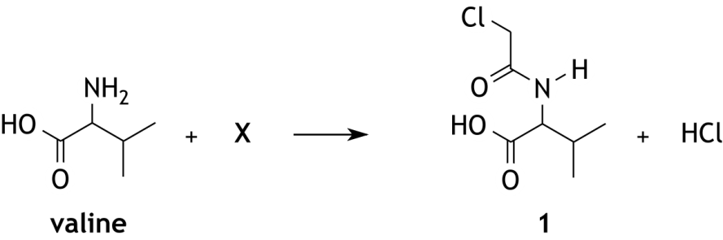
In the first reaction, the amino acid valine reacts with compound X to form compound 1. In this conversion, HCl is released as a byproduct.

- Write the structural formula of X. 2
The synthesis route continues as follows:
1 is reacted with acetic anhydride; in this reaction 2 (see below) is formed.
By increasing the temperature, 2 is converted into an intermediate product 3.
From 3, after the splitting of ethanoate and HCl, compound 4 is formed.
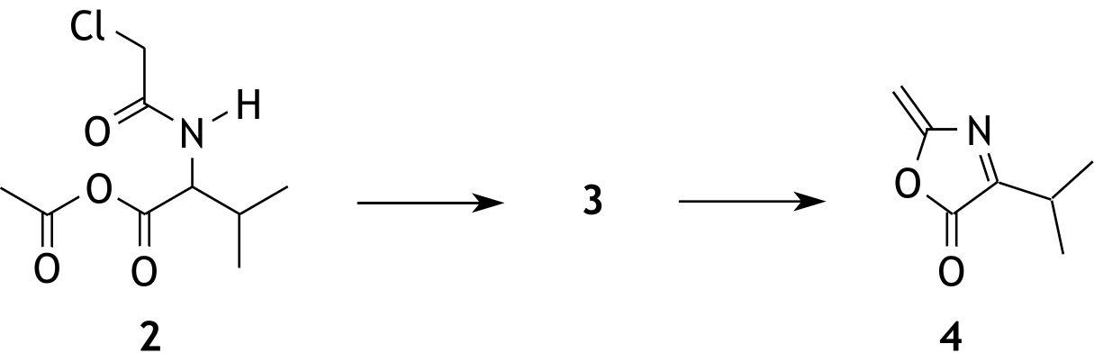

The mechanism of the conversion from 2 into 3 proceeds as follows:
- reaction of a base with the NH group;
- formation of a structure with a C = N bond;
- ring closure to form a structure with a five-membered ring.
On the worksheet with this test, the structural formula of 2 and B as formula for the base are represented.
- On the worksheet, show the mechanism of the conversion of 2 into 3 by:
- drawing the structural formulas of the products;
- drawing non-bonding electron pairs in the structural formulas before and after the arrow;

- using curly arrows ( ) to indicate how electron pairs shift during formation and breaking of bonds;
- placing formal charges at the appropriate positions. 4
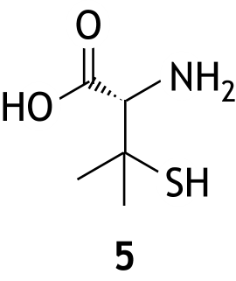
Through several reactions 4 is converted to compound 5, an important intermediate in the synthesis of penicillin.

- Explain whether compound 5 has the R- or S-configuration. Use a drawing in your explanation. 3
The bactericidal action of penicillin is based on the inhibition of bacterial cell wall formation. The cell wall of a bacterium consists, amongst other things, of a polysaccharide. Peptide chains, formed from a number of amino acids, are bound to this polysaccharide. The first amino acid bound to the polysaccharide is always alanine, with the amino group of alanine always linked to the polysaccharide. During the creation of the cell wall, two adjacent peptide chains are linked together. This linking is catalyzed by the enzyme transpeptidase. Two of such linkings are schematically shown below.
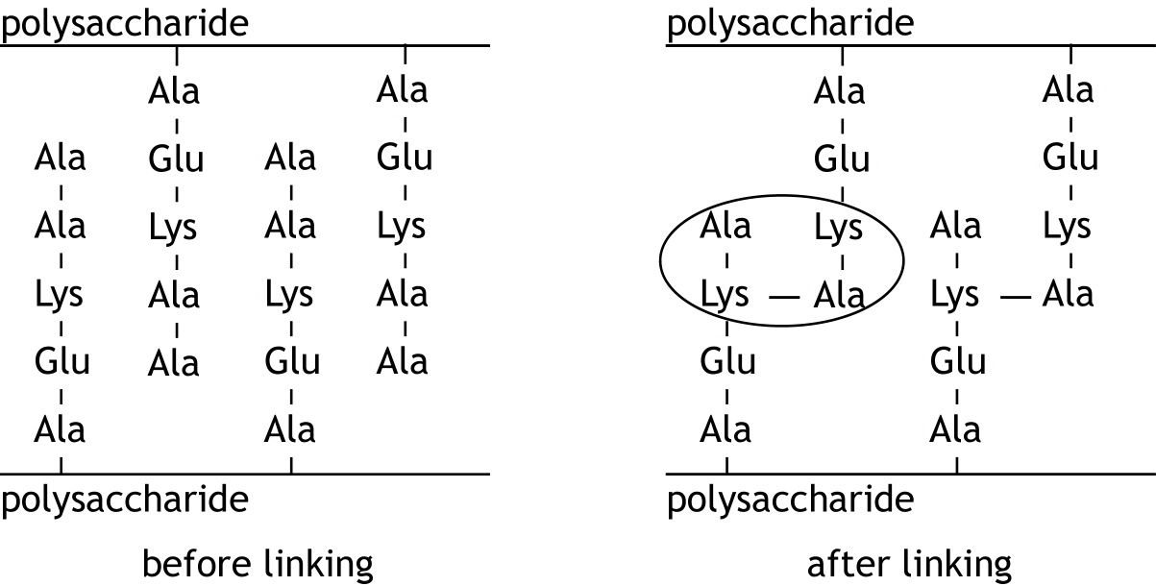

- Draw the structural formula of the ‘encircled’ part. From this structural formula, it should be clear how the four amino acid residues are linked. Use data from this problem and your data booklet. 4
Penicillin prevents the above mentioned linking of peptide chains because penicillin reacts with the enzyme transpeptidase. In this process, the penicillin molecule binds to the enzyme. This reaction is irreversible.
The resulting substance is not enzymatically active. Transpeptidase is a polypeptide.
A molecule of transpeptidase contains, amongst other things, a serine unit. In the reaction between penicillin and transpeptidase, the side chain of the serine unit reacts with the peptide bond in the core of a penicillin molecule. In this process that peptide bond is broken and an ester is formed.
On the worksheet with this test, the reaction equation of the reaction between penicillin and transpeptidase is partially shown. The molecule transpeptidase containing the side chain of the serine unit is schematically represented as follows:
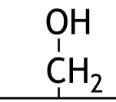

- On the worksheet, complete the reaction equation between penicillin and transpeptidase. Show the product of this reaction as a structural formula, similar to the way it was done before the arrow for penicillin and transpeptidase. 3

Green Chemistry

The twelve principles of green chemistry are:

1. Prevention Preventing waste is better than treating or cleaning up waste after it is created.
2. Atom economy Synthetic methods should try to maximize the incorporation of all materials used in the process into the final product. This means that less waste will be generated as a result.
3. Less hazardous chemical syntheses Synthetic methods should avoid using or generating substances toxic to humans and/or the environment.
4. Designing safer chemicals Chemical products should be designed to achieve their desired function while being as non-toxic as possible.
5. Safer solvents and auxiliaries Auxiliary substances should be avoided wherever possible, and as non-hazardous as possible when they must be used.
6. Design for energy efficiency Energy requirements should be minimized, and processes should be conducted at ambient temperature and pressure whenever possible.
7. Use of renewable feedstocks Whenever it is practical to do so, renewable feedstocks or raw materials are preferable to non-renewable ones.
8. Reduce derivatives Unnecessary generation of derivatives — such as the use of protecting groups — should be minimized or avoided if possible; such steps require additional reagents and may generate additional waste.
9. Catalysis Catalytic reagents that can be used in small quantities to repeat a reaction are superior to stoichiometric reagents (ones that are consumed in a reaction).
10. Design for degradation Chemical products should be designed so that they do not pollute the environment; when their function is complete, they should break down into non-harmful products.
11. Real-time analysis for pollution prevention Analytical methodologies need to be further developed to permit real-time, in-process monitoring and control before hazardous substances form.
12. Inherently safer chemistry for accident prevention Whenever possible, the substances in a process, and the forms of those substances, should be chosen to minimize risks such as explosions, fires, and accidental releases.

atom economy
percentage yield
E-factor

45th National Chemistry Olympiad 2024 preliminary round 2
Answer sheet multiple choice questions

name:

no. | choice  letter | (score)
1
2
3
4
5
6
7
8
9
10
11
12
13
14
15
16
17
18
19
20
 | Total

NATIONAL CHEMISTRY OLYMPIAD 2024

PRELIMINARY ROUND 2

Worksheet

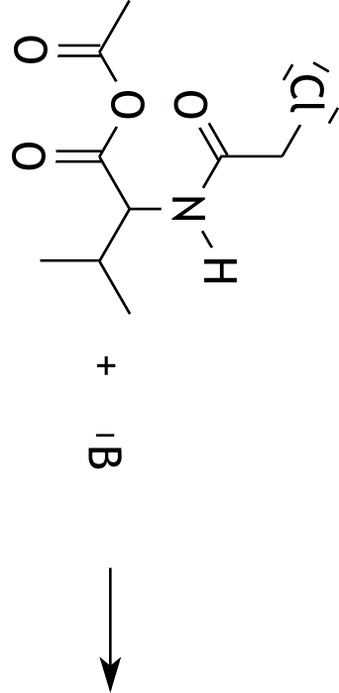
Question 12

Question 15
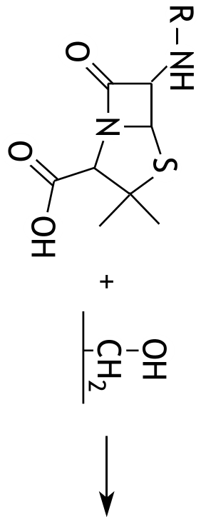

45th National Chemistry Olympiad

Maastricht University

THEORY TEST

Question booklet

Wednesday June 5, 2024

- This test consists of 7 problems with 32 open questions, an information sheet and an answer sheet.
- Use a separate answer sheet for each problem, making sure to write your name on each sheet. Maintain a 2 cm margin on all sides of the page.
- The maximum score for this test is 120 points.
- The test will last a maximum of 4 clock hours.
- Required resources: (graphic) calculator and Binas 6th or 7th edition or BINAS 5th edition, English version or ScienceData 1st print.
- For each question the number of points you can score are given.
- Unless otherwise stated, standard conditions apply: T = 298 K and p = p₀.

- NF 12 points
Nitrogen monofluoride, NF, is a metastable compound that has been observed during laser research.
Below and on the answer sheet, the initial setup for an MO diagram of nitrogen monofluoride is shown. The 1s, 2s, and 2p levels of the nitrogen atom have already been drawn in this diagram.
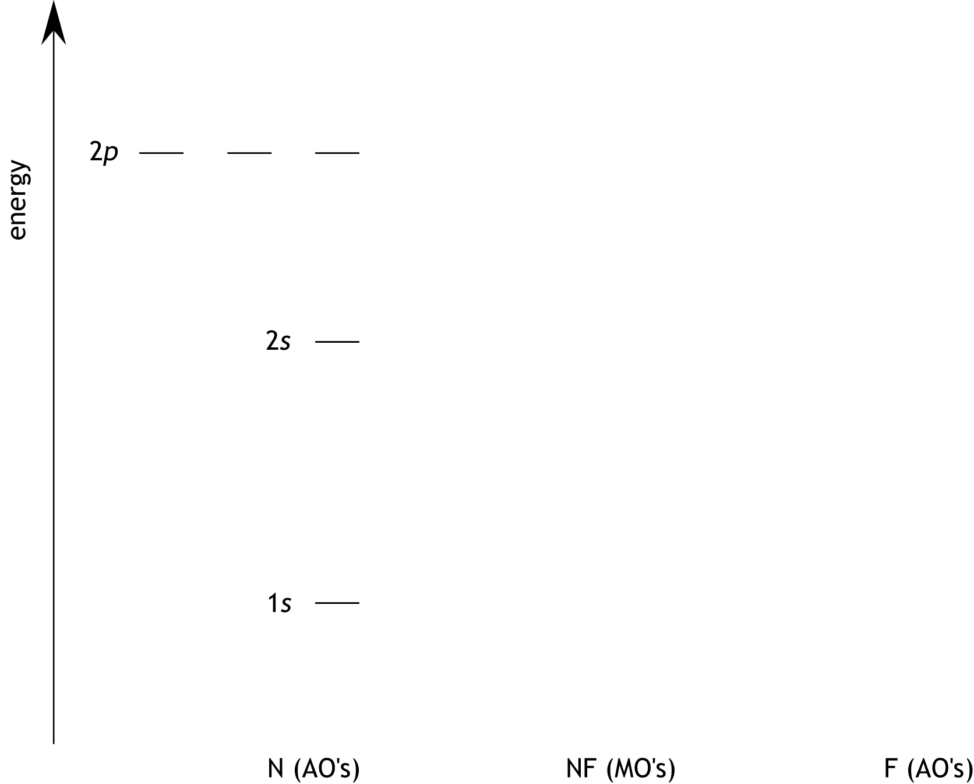

- Draw in the diagram on the answer sheet:
- the 1s, 2s, and 2p levels of the fluorine atom;
- the molecular orbitals of the nitrogen monofluoride molecule with the usual designations for 'bonding' and 'anti-bonding';
- the filling of electrons in the atomic and molecular orbitals according to the Aufbau principle. 7
- Calculate the bond order (BO) of the nitrogen monofluoride molecule. 2
- Give the Lewis structure of the nitrogen monofluoride molecule. 3

- Dinitrogen pentoxide 19 points
From the elements nitrogen and oxygen, various compounds exist. One of these is dinitrogen pentoxide, N₂O₅(g).
- Represent the N₂O₅ molecule in a Lewis structure. Place any formal charges in the correct positions.
Hint: each N atom is bonded to three O atoms, and there is no cyclic structure involved. 3
- Explain whether it is possible for all seven atoms of the N₂O₅ molecule to lie in one plane. 3
Below are three reactions involving nitrogen oxides, along with their corresponding standard reaction enthalpies.
2 NO(g) + O₂(g) → 2 NO₂(g) Δ_{r}H⁰₁ = − 116.2 kJ per 2 moles of NO₂
4 NO₂(g) + O₂(g) → 2 N₂O₅(g) Δ_{r}H⁰₂ = − 106.2 kJ per 2 moles of N₂O₅
N₂(g) + O₂(g) → 2 NO(g) Δ_{r}H⁰₃ = + 182.6 kJ per 2 moles of NO
- Calculate the standard enthalpy of formation Δ_{f}H⁰ of N₂O₅ in kJ mol⁻¹. Use only the standard reaction enthalpies provided above. 3
Dinitrogen pentoxide can be part of the following equilibrium:
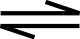
N₂O₅(g) NO₂(g) + NO₃(g)
The reaction enthalpy of this equilibrium is + 94.83 kJ mol⁻¹ at T = 600 K and p = p₀. In the table below, the entropies are given:
 | S (J mol⁻¹ K⁻¹) at T = 600 K and p = p₀
N₂O₅(g) | 426
NO₂(g) | 269
NO₃(g) | 293
- Calculate the equilibrium constant K_{p} at T = 600 K and p = p₀ for the above equilibrium. 5
An equilibrium mixture of N₂O₅(g), NO₂(g), and NO₃(g), which is formed from N₂O₅(g), has a total pressure of 0.10 bar at 600 K.
- Calculate how many moles of N₂O₅ per original mole of N₂O₅ have been converted to NO₂ and NO₃.
If you couldn't calculate K_{p} in question 7, use the value 0.060 for K_{p}. This is not the correct value. 5

- Chromium 21 points
The metal chromium can be obtained by means of the electrolysis of a solution called chromic acid. This solution is obtained from the chromium ore chromite. The formula of chromite can be represented as Cr₂O₃.FeO.
To obtain chromic acid from chromite, the chromite is first heated with sodium carbonate in the presence of air. This results in the formation of sodium chromate (Na₂CrO₄), iron(III) oxide, and carbon dioxide.
- Give the reaction equation for this conversion. 4
Subsequently, solid sodium chromate is isolated from the resulting solid mixture of sodium chromate and iron(III) oxide.
- Describe how you can obtain solid sodium chromate from the resulting solid mixture of sodium chromate and iron(III) oxide. 3
Chromic acid is formed by adding a solution of sulfuric acid to sodium chromate. In the resulting solution, all chromate is converted to dichromate (Cr₂O₇²⁻).
- Give the reaction equation for the conversion of chromate to dichromate. 3
During the electrolysis of chromic acid, chromium is formed at the negative electrode. It appears that not all dichromate is converted to metallic chromium in such an electrolysis. A small percentage is converted to Cr³⁺. During the execution of such an electrolysis, 95.0% of the Cr₂O₇²⁻ is converted to Cr and 5.0% to Cr³⁺.
- Calculate the percentage of the current absorbed at the negative electrode by Cr₂O₇²⁻ that was used to directly convert Cr₂O₇²⁻ to Cr. 4
The unit cell of the crystal lattice of metallic chromium is a body-centered cubic (bcc) structure.
- Prove this by means of a calculation using data from the data booklet. 7

- Methyl isocyanide 15 points
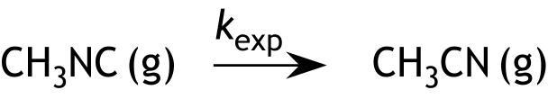
The compound methyl isocyanide can be converted to acetonitrile via an isomerization reaction according to:

From experiments, it is evident that this reaction is a first-order reaction at high pressure and a second-order reaction at low pressure.
The mechanism of this isomerization reaction consists of two steps.
In a first step, a molecule of methyl isocyanide is activated to CH₃NC* by collision with another molecule of methyl isocyanide. With this activated molecule, the following can occur:
- it is converted back to the original molecule of methyl isocyanide by collision with an inactivated molecule of methyl isocyanide;
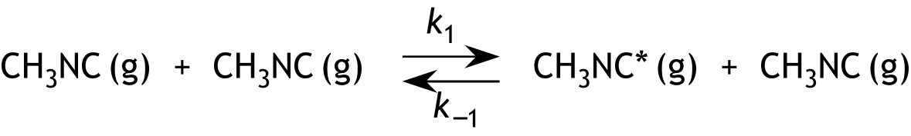
- it reacts in a second step to form a molecule of the isomer acetonitrile.
(1)
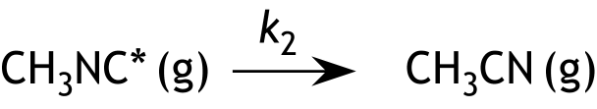
(2)
Using the ‘steady-state’ approximation, it can be derived that the rate equation for the formation of acetonitrile according to this mechanism is equal to:
- Give this derivation. 7
- Derive the expression for k_{exp} using the rate equation given above question 14. 2
With the help of the above rate equation, it can be derived that the conversion of methyl isocyanide to acetonitrile is a first-order reaction at high pressure and a second-order reaction at low pressure. This is because at high pressure s_{—1} >> s₂, and at low pressure s_{—1} << s₂. Here, s_{—1} represents the rate of the reaction to the left in equilibrium (1), and s₂ represents the rate of reaction (2).
- Explain that at high pressure s_{—1} >> s₂ and at low pressure s_{—1} << s₂. 2
- Explain, based on the above data, that the conversion of methyl isocyanide to acetonitrile is a first-order reaction at high pressure and a second-order reaction at low pressure. 4

- Electrochemical cell 15 points
We construct the following electrochemical cell at 298 K:
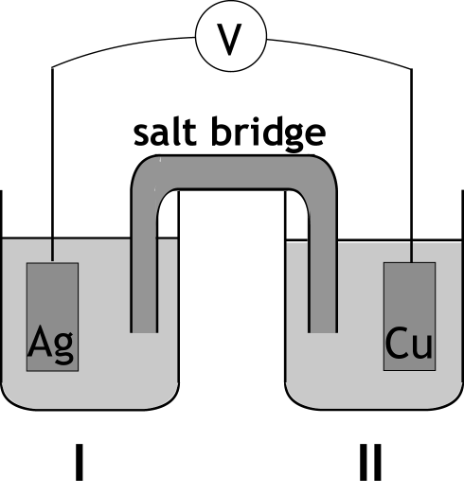

This cell consists of:
- half-cell I: a silver plate of 15.00 g in 1.00 L of 0.150 M AgNO₃ solution;
- half-cell II: a copper plate of 30.00 g in 1.00 L of 0.300 M CuSO₄ solution.
- Calculate the electromotive force (EMF) of this cell. 3
The cell is allowed to deliver a current of 0.200 A until the mass of the silver electrode is equal to the mass of the copper electrode.
- Calculate the number of seconds the cell supplies this current until that point is reached. 6

With the original electrochemical cell, the following actions are performed:
- Adding a sodium carbonate solution to half-cell I.
- Adding a sodium carbonate solution to half-cell II.
- Adding a sodium chloride solution to half-cell II.
- Explain for each of these actions whether it lowers or raises or whether that action has no effect on the electromotive force. 6

- Barbituric acid 13 points
Barbituric acid is a monoprotic weak acid, denoted as HZ in this problem. The value of K_{a} of HZ at 298 K has been determined spectrophotometrically. The fact that that both HZ and Z⁻ absorb ultraviolet light is used in this determination.
To determine the value of K_{a} of HZ, three buffer solutions were prepared with pH values of 2.00, 3.60, and 7.20, respectively. Equal amounts of these three buffer solutions were added to equal amounts of a very dilute solution of HZ.
It can be assumed that:
- in the solution with pH = 7.20, all HZ is converted to Z⁻;
- in the solution with pH = 3.60, a part of the HZ is converted to Z⁻;
- in the solution with pH = 2.00, none of the HZ has dissociated into ions.
The obtained solutions were measured (at 298 K) for their absorbance (extinction) A with ultraviolet light of different wavelengths between 200 and 280 nm.
The same cuvette was used for all measurements.
In the diagram on the information sheet, the results of the measurements on the three solutions are shown. Using the Lambert-Beer law, the measured absorbances were converted to the absorbances that would apply if the (total) concentration of HZ and/or Z⁻ were 1.00 mol L⁻¹ in each of the three solutions.
The absorbances in the diagram therefore apply in the following cases:
- [Z⁻] in the solution with pH = 7.20 would be equal to 1.00 mol L⁻¹;
- [HZ] + [Z⁻] in the solution with pH = 3.60 (together) would be equal to 1.00 mol L⁻¹;
- [HZ] in the solution with pH = 2.00 would be equal to 1.00 mol L⁻¹.
An absorbance measured from a solution with pH = 3.60 is the sum of the absorbances caused by Z⁻ and HZ separately. The graphs corresponding to pH = 7.20 and pH = 2.00 intersect at point A (at wavelength 221 nm). The graph corresponding to pH = 3.60 is not fully displayed: the part of the graph at wavelengths less than 235 nm has been omitted.
- Explain whether the fully displayed graph corresponding to pH = 3.60 also passes through point A. 3
With the help of the three absorbances (from the diagram) at a certain wavelength, one can calculate the ratio between [Z⁻] and [HZ] in the solution with pH = 3.60.
- Provide the values of the three absorbances in the diagram at 257 nm (at pH values of 2.00, 3.60, and 7.20, respectively). 2
- Calculate, based on the values of the three absorbances, the ratio [Z⁻] : [HZ] in the solution with pH = 3.60. 5
- Calculate the value of K_{a} (298 K) of barbituric acid (HZ). 3
If you couldn't calculate the requested ratio in question 23, take the answer to question 23 as [Z⁻] : [HZ] = 0.55 : 1.0. This is not the correct answer to question 23.

- Melphalan 25 points
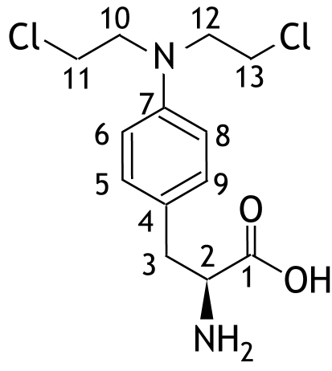
Melphalan (as shown below) is a medication used in the treatment of various types of cancer.

In the above structural formula of Melphalan, the carbon atoms are numbered. Melphalan exists as two enantiomers, that are both used. The enantiomer depicted above exhibits the highest activity.
- Give the number of the stereocenter of the depicted enantiomer and explain its absolute configuration (R/S). 4
In the ¹H  NMR-spectrum of Melphalan, the following signals of protons bound to carbon atoms are observed:
chemical shift  (ppm) | multiplicity | integral | number(s) of C atom(s)
2.8 | doublet | 2 H
3.5 | triplet | 4 H
3.6 | triplet | 1 H
3.9 | triplet | 4 H
6.7 | doublet | 2 H
6.8 | doublet | 2 H
The same table is provided on the answer sheet.
- Fill in, on the answer sheet, the numbers of the carbon atoms corresponding to the listed signals. Use NMR data from the data booklet. 4
On the information sheet the synthesis route of Melphalan, starting from phenylalanine is given.
- Provide the structural formulas of A and B. 2
In step 1, the aromatic part of phenylalanine molecules is primarily nitrated at the para-position. During this nitration, the ortho-positions are also nitrated, but to a much lesser extent than would be expected based on statistical and electronic factors that control the regioselectivity of this nitration.
The meta-positions are hardly nitrated.
- Why are the meta-positions hardly nitrated? 2
- Why are the ortho-positions nitrated to a much lesser extent than would be expected based on statistical and electronic factors that control the regioselectivity of this nitration? 2
The reaction in step 5, where D is converted to E, can be understood as an acid-catalyzed nucleophilic substitution. The mechanism of the reaction of a molecule of D with one molecule epoxyethane starts with the protonation of a molecule of epoxyethane.
- Present the mechanism of the reaction of a molecule of D with one molecule of epoxyethane by:
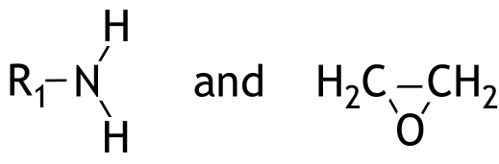
- using the structural formulas, shown below, for D and epoxyethane, respectively;
;
- depicting lone pairs;
- using curly arrows ( ) to indicate how electron pairs shift during formation and breaking of bonds;
- placing formal charges at the correct positions;
- drawing the structural formula of the product formed by the reaction of a molecule D with one molecule of epoxyethane. 5
The conversion that occurs in step 4 can be termed selective.
- Explain this. 2
In the synthesis route, the introducing and afterwards removing of a protecting group is used twice.
- For each protection, indicate:
  - in which step the protection is introduced and in which step it is removed;
  - the reason why the protection in question is necessary. 4

This test was created with thanks to the cooperation of the following people:
Dr. Chris Bahn
Dr. Burgert Blom
Dr. Hanne Diliën
Dr. Maarten Honing
Dr. Geert Hooyberghs
Dr. Giuditta Perversi
Dr. Erik Steen Redeker
Dr. Veaceslav Vieru
The final editing was done by:
Drs. Kees Beers, drs. Dick Hennink, ir. Piet Mellema and dr. Pia Scheffer
The exam was translated into English by:
Marijn Jonker, MSc., drs Jan Rombach

45th National Chemistry Olympiad

Maastricht University

THEORY TEST

Information sheet

Wednesday June 5, 2024

Barbituric acid

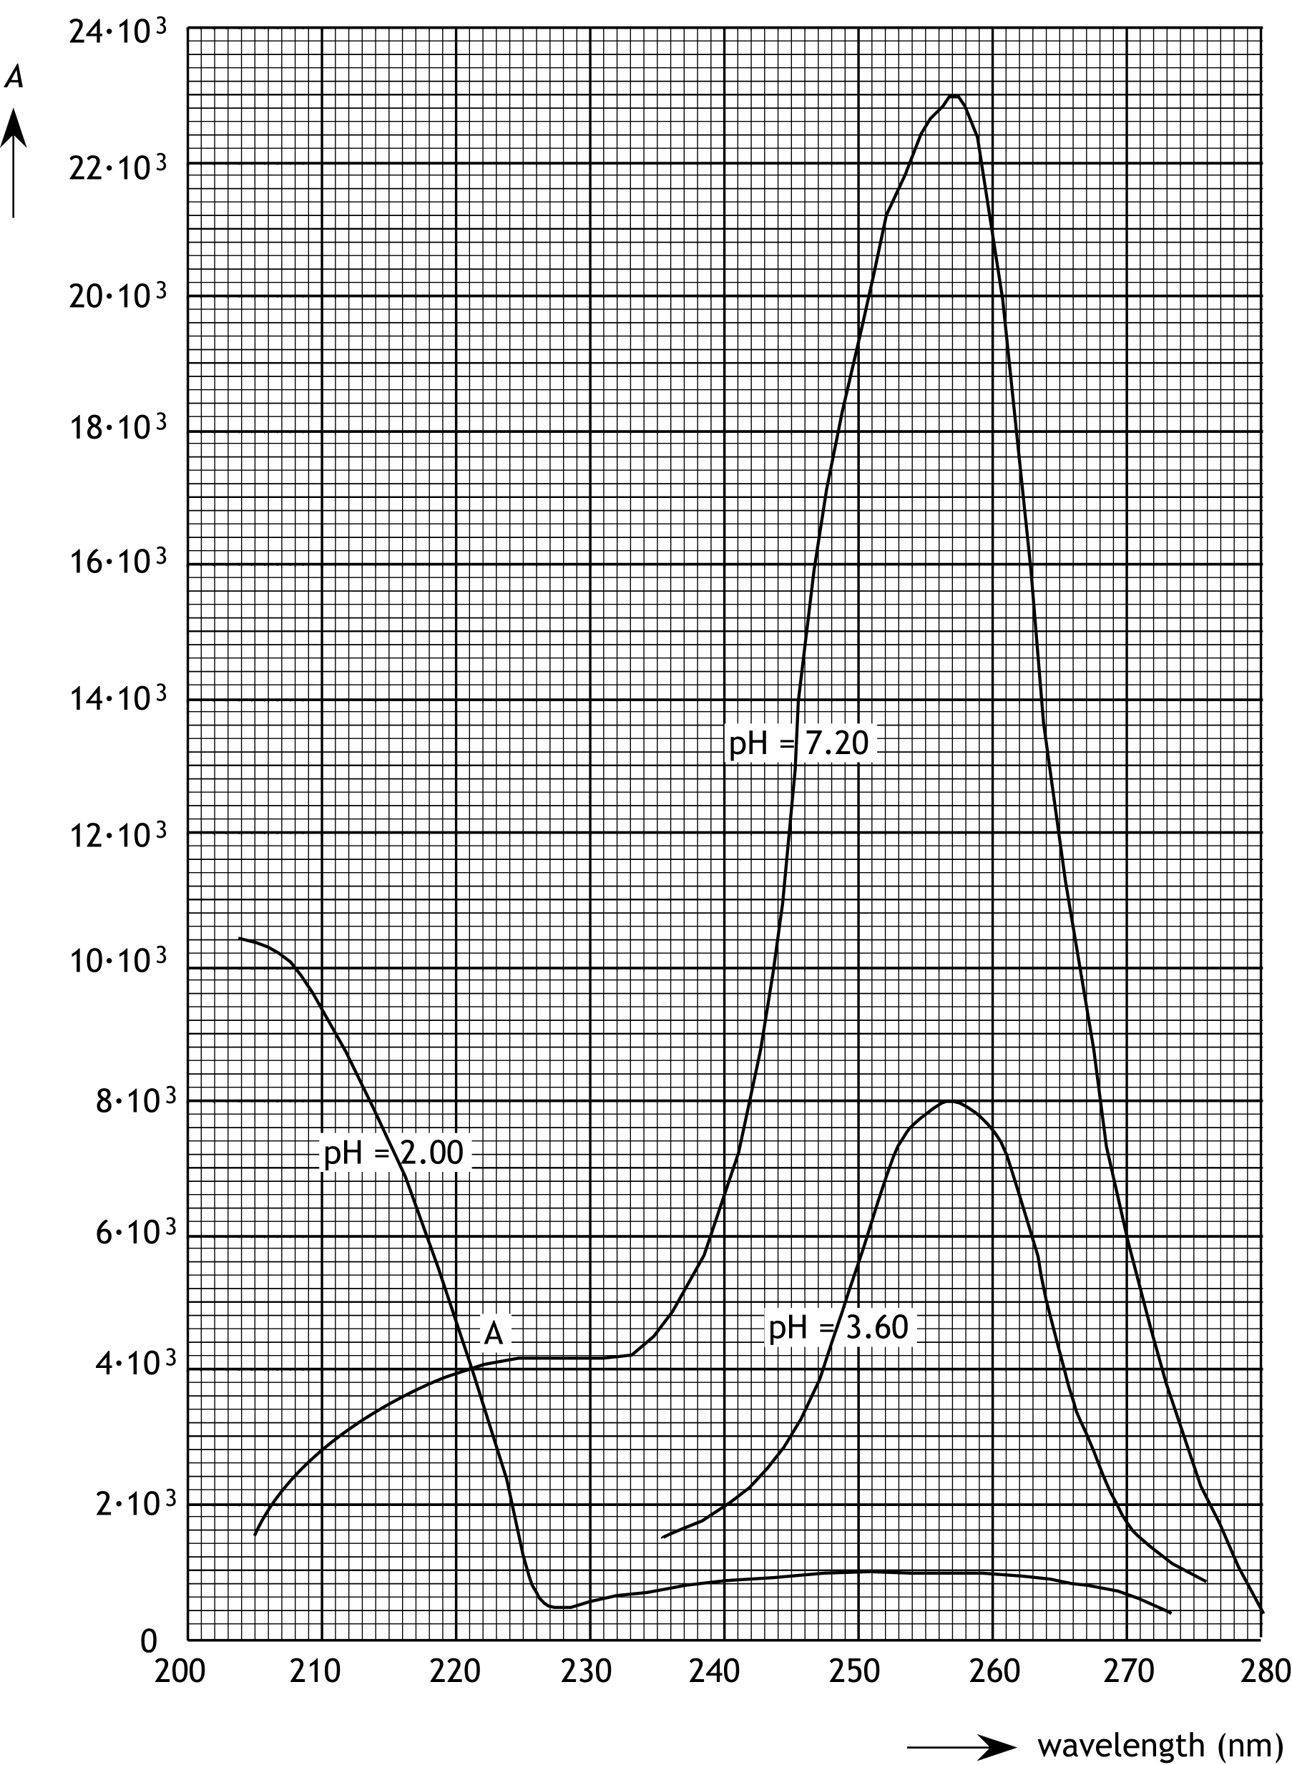

Melphalan

synthesis route
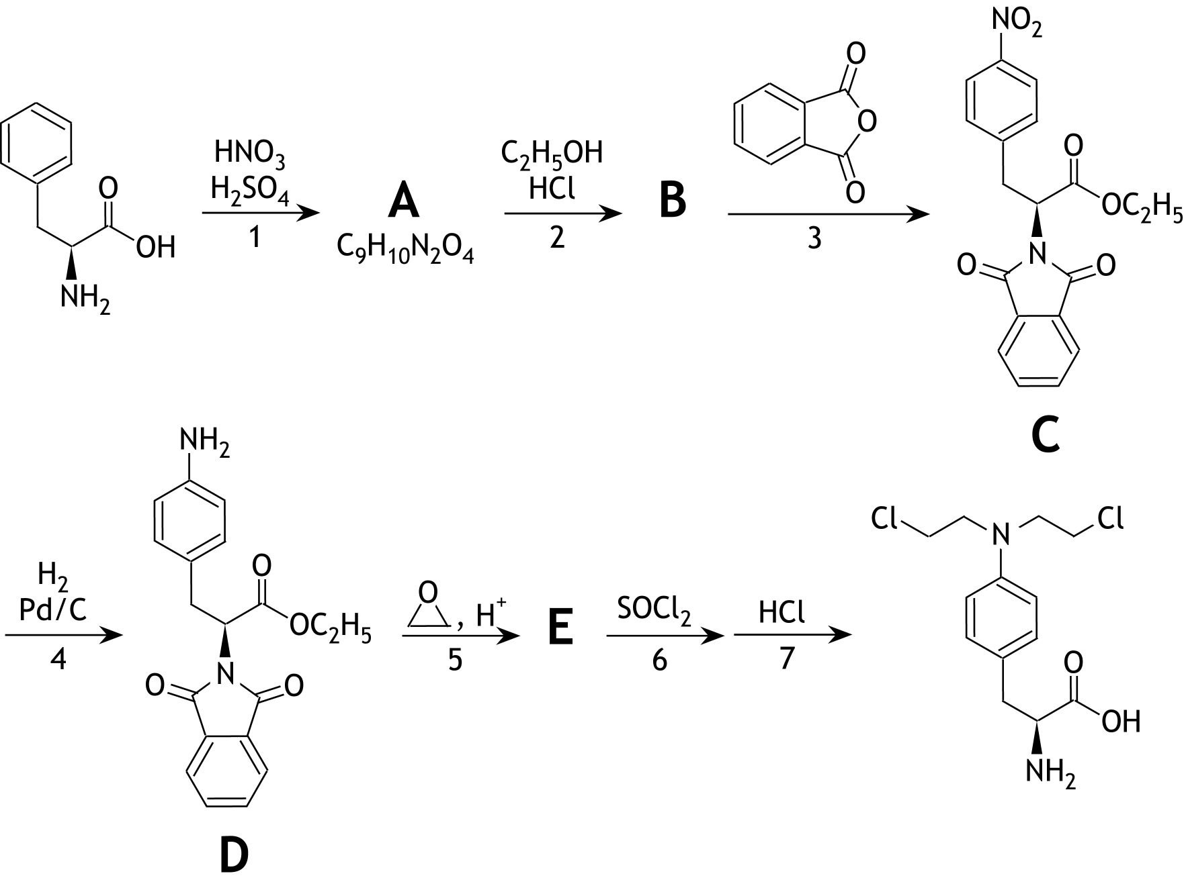

45th National Chemistry Olympiad

Maastricht University

THEORY TEST

Answer sheet

Wednesday June 5 2024

Name:

N.B.: Don’t forget to write your name on the front page!

Question 1

Question 26

chemical shift  (ppm) | multiplicity | integral | number(s) of C atom(s)
2.8 | doublet | 2 H
3.5 | triplet | 4 H
3.6 | triplet | 1 H
3.9 | triplet | 4 H
6.7 | doublet | 2 H
6.8 | doublet | 2 H

45th National Chemistry Olympiad

Maastricht University

PRACTICAL TEST

Assignment booklet

Thursday June 6, 2024

The experiments for this test were prepared by:
Dr. Kathia Jimenez Monroy
Richard Matysek
Joeri Noordijk
Dr. Giuditta Perversi
Dr. Erik Steen Redeker
Dr. Veaceslav Vieru

The NSO committee:
Emiel de Kleijn

The final editing was done by:
Drs. Kees Beers, drs. Dick Hennink
The exam was translated into English by:
Drs. Kees Beers, drs. Dick Hennink, drs. Jan Rombach

Directions/resources
- This practical test consists of two parts:
  - The determination of the amount of crystal water (x) in a mixture of
Na₂CO₃.xH₂O and NaHCO₃.
  - Kinetic study of the decomposition of tris-(oxalato)-manganate(III) ions.

- The practical test ends after 4 hours. During this time:
  - the attached answer sheets need to be completed;
  - all questions must be answered.

- After the practical test, when you have handed in everything, the glassware still needs to be cleaned and tidied up.

- The maximum score for the practical test is 80 points.

- The score is determined by:
  - practical skills, working clean, safety maximum 20 points
  - results of the determinations and answers to the questions maximum 60 points

- Required tools: (graphic) calculator, ruler/protractor triangle and Binas or ScienceData.

- First read the introduction and all assignments before you start working.

- Write the answers to the questions in the boxes on the answer sheets provided. If you don't have enough space, you can ask for extra paper.

Additional:
- This is a test; it is not permitted to consult with other participants.
- If you have a question, you can ask the supervisor.
- If something is wrong with your glassware or equipment, report it to the supervisor as soon as you discover it. Don't borrow someone else's things!

- The determination of the amount of crystal water (x) in a mixture of Na₂CO₃.xH₂O and NaHCO₃ 40 points
Introduction
Sodium carbonate is mined mostly from a mineral named Trona. It is a mixture of hydrated sodium carbonate (Na₂CO₃.xH₂O) and sodium hydrogen carbonate (NaHCO₃).
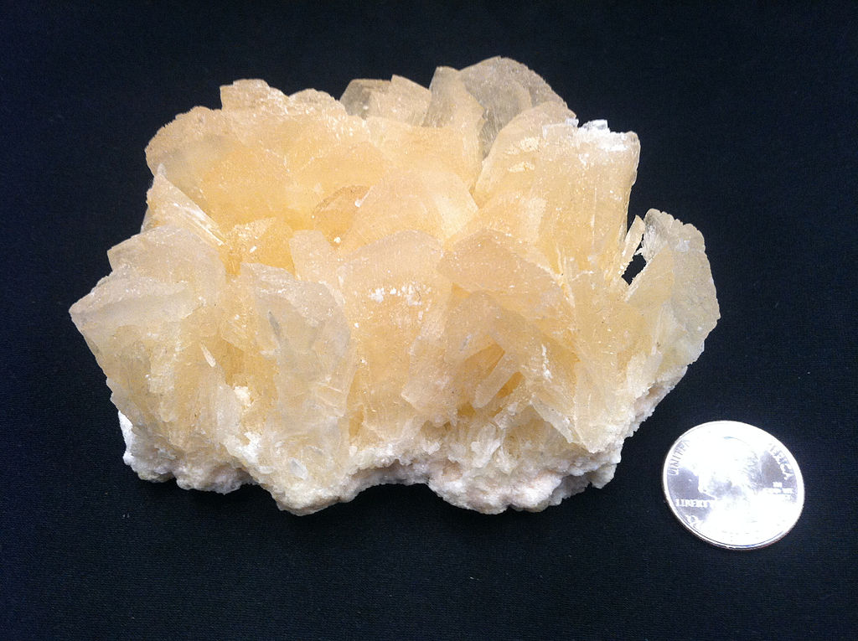

The goal of this task is to determine the amount of crystal water bound to sodium carbonate in a solid mixture containing hydrated sodium carbonate (Na₂CO₃.xH₂O) and sodium hydrogen carbonate (NaHCO₃).
In this determination two separate titrations with a solution of hydrochloric acid are performed:
- a titration with methyl orange as the indicator
- a titration with phenolphthalein as the indicator.
Each titration is executed in duplicate. In advance, you have to execute a test titration.
Chemicals
- a weighed mixture of Na₂CO₃.xH₂O and NaHCO₃
- 0.1000 M hydrochloric acid
- a solution of methyl orange
- a solution of phenolphthalein
- demineralized water
Safety
- wear safety glasses
- if your skin comes into contact with any of the chemicals, rinse it immediately
Equipment and glassware
- 250 mL volumetric flask
- funnel for the volumetric flask
- 50 mL burette
- funnel for the burette
- four beakers
- four small plastic pipettes
- pipette-balloon
- 25 mL pipette
- 50 mL Erlenmeyer flask for the titrations
- marker
- magnetic stirrer
- magnetic stir bar
Procedure
- Prepare a solution of your solid sample in the 250 mL volumetric flask.
- Fill the burette with the 0.1000 M hydrochloric acid.
Note: Probably you have to refill the burette a few times during the determination.
- With each of the titrations below, first perform a test titration. Afterwards perform each titration in duplicate.
Titration in presence of phenolphthalein
- Add 25.00 mL of the solution that is in the volumetric flask to the 50 mL Erlenmeyer flask.
- Add three drops of the phenolphthalein solution.
- Put the magnetic stir bar in the solution and start stirring (don’t heat).
- Titrate until the pink colour disappears totally.
- Repeat steps 4 to 7.
Titration in presence of methyl orange
- Add 25.00 mL of the solution that is in the volumetric flask, to the 50 mL Erlenmeyer flask.
- Add three drops of the methyl orange solution.
- Titrate until the colour becomes red.
- Repeat steps 9 to 11.

Questions – write the answers on the answer sheets
- Write down:
  - the mass of the sample
  - the molarity of the hydrochloric acid
  - all burette readings 8
- Give the equations of the reactions that occur during the titrations. 4
- Calculate the amount of mmoles of Na₂CO₃.xH₂O and the amount of mmoles of NaHCO₃ in your sample. 10
- Calculate the value of x in Na₂CO₃.xH₂O. 4
- It is also possible to perform the determination by using a precipitation reaction (and weighing the precipitate) instead of one of the titrations.
Explain which solution could be used and which titration does not have to be executed in that case. 4
- Kinetic study of the decomposition of tris-(oxalato)-manganate(III) ion 40 points
Introduction
When solutions of manganese(II) sulfate, potassium permanganate and oxalic acid are poured together, so called tris-(oxalato)-manganate(III) ions, {Mn(C₂O₄)₃}³⁻ are formed according the reaction equation below:
MnO₄⁻ + 4 Mn²⁺ + 15 H₂C₂O₄ → 5 {Mn(C₂O₄)₃}³⁻ + 22 H⁺ + 4 H₂O reaction 1
As soon as these ions are formed, they begin to decompose and Mn²⁺, C₂O₄²⁻ and CO₂ are formed:
2 {Mn(C₂O₄)₃}³⁻ → 2 Mn²⁺ + 5 C₂O₄²⁻ + 2 CO₂ reaction 2
The rate equation of reaction 2 can be given as:
The goal of this experiment is:
- to show that reaction 2 is a first order reaction;
- to determine the value of the rate constant k.
Because the ions {Mn(C₂O₄)₃}³⁻ give the solution a light brown colour (λ_{max} = 440 nm) and the reaction products are colourless, the course of the reaction can be followed spectrophotometrically by measuring regularly the absorbance (extinction) A of the solution.
The average reaction rate in a time interval Δt can be calculated by using the expression below:
In this expression ΔA is the change in the absorbance (extinction) in the time interval Δt and is [{Mn(C₂O₄)₃}³⁻] the concentration of the complex at the beginning of that time interval.
Further applies that ε = 70 L mol⁻¹ cm⁻¹ and l = 1.00 cm.
The experiment is executed in two variants, with two sets of solutions that differ in concentration.
To execute the measurements with the spectrophotometer you can get help from the lab assistant.
Chemicals
- solutions of MnSO₄: 0.20 M and 0.075 M
- solutions of H₂C₂O₄: 0.20 M and 0.075 M
- solutions of KMnO₄: 0.020 M and 0.0075 M
Safety
- wear safety glasses
- if your skin comes into contact with any of the chemicals, rinse it immediately.
Materials
- a 2 mL pipette
- a 10 mL pipette
- a 25 mL pipette
- three plastic pipettes
- three UV cuvettes
- pipette-balloon
- two 50 mL Erlenmeyer flasks
- four beakers
- magnetic stirrer
- magnetic stir bar
- stopwatch
Procedure
Variant I
- Introduce successively into the 50 mL Erlenmeyer flask: 2.0 mL of 0.20 M solution of MnSO₄ and 14.0 mL of 0.20 M solution of H₂C₂O₄.
- Put the magnetic stir bar into the solution and start stirring (don’t heat).
- Add 4.0 mL 0.020 M solution of KMnO₄ and start timing.
- Immediately after starting timing, take a sample from the reaction vessel with the plastic pipette, bring it into a cuvette and measure the absorbance .
- Write down, in the designated table of your answer sheet, the measured absorbance and the time of the measurement.
- Pour back the solution from the cuvette into the reaction vessel.
- After about 60 s, take another sample from the solution and measure the absorbance. Write down, in the table of your answer sheet, the absorbance and the time of the measurement.
- Pour back the solution from the cuvette into the reaction vessel.
- Repeat steps 7 and 8 three times approximately every 60 s.
Variant II
- Repeat steps 1 to 7 of the procedure of variant I, but now use 0.075 M solution of MnSO₄, 0.075 M solution of H₂C₂O₄ and 0.0075 M solution of KMnO₄.

Questions – write the answers on the answer sheets
- Write down, in the designated tables of your answer sheet, all measured absorbances and the times of the measurements of the absorbances. 2
- Calculate the reaction rate in the first time interval for both variants.
Write down your calculation in the designated tables of your answer sheet. 2
The order of the reaction can be calculated by means of the formula below:
In this formula s_{I} and s_{II} are the reaction rates in the first time interval of variant I and variant II, respectively. [{Mn(C₂O₄)₃}³⁻] _{I} and [{Mn(C₂O₄)₃}³⁻] _{II} are the initial concentrations of the complex ion in the first time interval of both variants. These approximately equal the concentrations of the complex ion on t = 0: [{Mn(C₂O₄)₃}³⁻] _{I} = 0.020 mol L⁻¹ and [{Mn(C₂O₄)₃}³⁻] _{II} = 0.0075 mol L⁻¹.
- Calculate n using your measurements. 8
- Does it follow from your measurements that reaction 2 is a first order reaction? Motivate your answer. 2
- Calculate the reaction rates in the second, third and fourth time interval of variant I. Write down your calculations in the designated table of your answer sheet. 3
- Calculate the average rate constant k that follows from this, assuming that reaction 2 is a first order reaction.
Write down your calculations in the designated table of your answer sheet. 9
- Show, by means of a calculation, that the initial concentration of {Mn(C₂O₄)₃}³⁻ in variant I equals 0.020 mol L⁻¹. 4

45th National Chemistry Olympiad

Maastricht University

PRACTICAL TEST

Answer sheets

Thursday June 6, 2024

NB.: Write your name at the top of every page!

Practical test answer sheets
Experiment 1
Question 1
mass of the sample:
molarity of the hydrochloric acid:

burette readings for the titration with phenolphthalein
titration | initial reading | final reading | used volume | average used volume (V₁)
test titration
1
2

burette readings for the titration with methyl orange
titration | initial reading | final reading | used volume | average used volume (V₂)
test titration
1
2

Question 2
with phenolphthalein:

with methyl orange:

Question 3

Question 4

Question 5

Practical test answer sheets
Experiment 2
Questions 6, 7, 10 and 11
Variant I
t (s) | A | Δt (s) | ΔA | s | k

k_{average} =
Variant II
t (s) | A | Δt (s) | ΔA | s

Question 8
Question 9
Question 12

NATIONAL CHEMISTRY OLYMPIAD 2024

MARKING SCHEME PRELIMINARY ROUND 1

To be conducted from 15 until 31 January 2024

- This preliminary round consists of 25 multiple choice questions divided over 9 topics and 2 problems with a total of 8 open questions as well as an answer sheet for the multiple choice questions.
- Use the answer sheet to answer the multiple choice questions.
- Use for each problem with open questions a separate answer sheet. Don’t forget to put your name on it.
- The maximum score for this work is 77 points.
- The preliminary round lasts up to two full hours.
- Required materials: (graphic) calculator and BINAS 6th or 7th edition, ScienceData 1st edition or BINAS 5th edition, English version.
- For each question the number of points you can score are given.
- Unless otherwise stated, standard conditions apply: T = 298 K and p = p₀.

- Multiple choice questions total 50 points

For every correct answer: 2 points
 |  | Carbon chemistry
1 | D | In step 1, an addition of HBr takes place to the double bond.  In step 2, Br is substituted by OH.
2 | B | 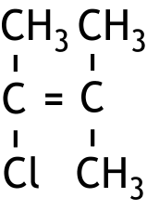  The polymer was created by addition polymerization of .
3 | B | At B, the chlorine atom can replace an H atom on C atom 1 or on C atom 2. The following monochloro substitution products are formed:  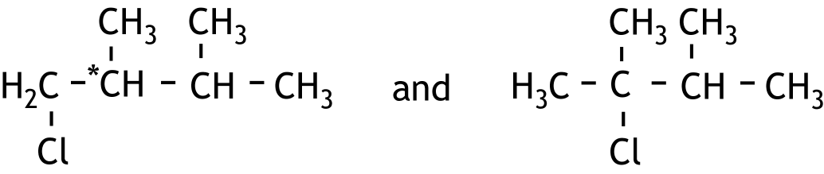  When the chlorine atom is placed on C atom 1, C atom 2 becomes an asymmetric C atom, indicated with an asterisk. There are therefore two mirror image isomers of that structure that have the same boiling point.  The other compounds produce more than three isomers.
4 | B | The electron pair from the bond between the O atom and the C atom becomes a lone pair on the O atom. The arrow must therefore point in the direction of the O atom.
 |  | Reaction rate and equilibrium
5 | D | When the solution is diluted, the equilibrium shifts to the right. The number of moles of H₃O⁺ increases. However, [H₃O⁺] becomes smaller. So the pH increases.
6 | A | mol C₅H₁₂O is converted in 4.0 × 60 sec.  So the reaction rate is
7 | C | K = [Ba²⁺][IO₃—]²  0.2000 — 0.1513 g Ba(IO₃)₂ has been dissolved, that is .  and .  So
8 | C | The reaction rate depends on the degree of distribution of the zinc, the concentration of H₃O⁺ and the temperature. These have all remained the same at C.

 |  | Thermochemistry
9 | A | For reaction 1 applies ΔH = — 0.133·10⁵ + 2 × 0.332·10⁵ = 0.531·10⁵ J per mol N₂O₅.  For reaction 2 applies ΔH = — 0.332·10⁵ + 0.913·10⁵ = 0.581·10⁵ J per mol NO₂.  For the total conversion, 0.725·10⁵ J per mol N₂O₅ was needed.  The number of moles of NO₂ that still has to be converted is therefore mol.  Per mole of N₂O₅, 2 moles of NO₂ are formed, so in reaction 2, % of the generated NO₂ is further converted.
 |  | Structures and formulas
10 | D | In structure A, the charges on the nitrogen atoms are incorrect.  In structures B and C the structures do not have enough electrons and the charges are also incorrect.
11 | B | In COCl₂, the C has a double bond to the O and a single bond to the Cl atoms. There are no lone pairs on the C atom. In the other answers, the indicated atoms have an electron domain geometry of 4.
12 | B | Hg⁺ has 79 electrons. I— has 54. Cu⁺ and Zn²⁺ have 28. Ni²⁺ has 26.
 |  | pH / acid-base
13 | C | B + H₂O HB⁺ + OH—  pOH = 14.00 — pH = 1.50  [OH—] = 10^{—1.50} = 0.032 mol L^{—1}
   |  | [B] |  | [HB⁺] |  | [OH—]
  initial |  | 0.15 |  | 0 |  | 0
  change | — | 0.032 | + | 0.032 | + | 0.032
  equilibrium |  | 0.12 |  | 0.032 |  | 0.032
14 | C | The sodium hydroxide solution contains 150 × 0.150 = 22.5 mmol OH—  and the hydrochloric acid contains 250 × 0.100 = 25.0 mmol H₃O⁺.  Therefore there is 25.0 — 22.5 = 2.5 mmol H₃O⁺ in excess.  The total volume is 150 + 250 = 400 mL, so

15 | F | HPO₄^{2—} + H₂O H₂PO₄— + OH—  pOH = 14.00 — 7.41 = 6.59; [OH—] = 10^{—6.59}  The mole ratio is therefore  0.62 mol NaH₂PO₄ (M = 120 g mol^{—1}) : 1.0 mol Na₂HPO₄ (M = 142 g mol^{—1}).  The mass ratio is  74.7 g NaH₂PO₄ : 142 g Na₂HPO₄ = 1.0 g NaH₂PO₄ : 1.9 g Na₂HPO₄.
 |  | Redox and electrolysis
16 | C | For the production of 1.0 g Li mol electrons are required.  For the production of 1.0 g Al mol electrons are required.  Therefore the production of 1.0 g Al takes times longer than the production of 1.0 g Li with the same current.
17 | C | The standard electrode potentials of the redox couples are:  Cr₂O₇^{2—}/Cr³⁺ + 1.36 V  MnO₄—/Mn²⁺ + 1.51 V  Therefore the oxidizing agent Cr₂O₇^{2—} cannot react with the reducing agent Mn²⁺.  NO₃—/NO₂ + 0.80 V  SO₄^{2—}/SO₂ + 0.17 V  Therefore the oxidizing agent NO₃— can react with the reducing agent SO₂.
 |  | Analysis
18 | D | 8.5 mL hydrochloric acid is required for 1.0 mL of the undiluted ammonia solution.  25.00 × 8.5 = 212.5 mL hydrochloric acid is required for 25.00 mL of the undiluted ammonia solution.  Between 12 mL and 25 mL hydrochloric acid should be used, therefore the dilution factor must be between and .  The dilution factors of A, B, C, D and E are respectively 25, 50, 4, 10 and 20.

19 | D | During the titration 14.36 × 0.00850 = 0.122 mmol of AgNO₃ was used.  Because Ag⁺ + Cl— → AgCl, this also makes 0.122 mmol Cl— in the 10.00 mL of the diluted sodium chloride solution. Which means that 10.00 mL of the diluted NaCl solution contained 0.122 mmol NaCl.  In 10.00 mL undiluted solution was present.  The molarity of the undiluted NaCl solution was: .
20 | G | Fragmentation of the molecules I en III will cause C₃H₇⁺ fragments that peak around m/z = 43.  Fragmentation of the molecule II will cause fragments of CH₃CO⁺ that peak around m/z = 43.
21 | A | At the first equivalence point at 6 mL sodium hydroxide solution only the stronger acid has completely reacted. At the second equivalence point, which is at 10 mL (so 4 mL later), the weaker acid has also completely reacted. Therefore, to completely convert a strong acid one needs more of the base, and the molarity of the strong acid is larger. This means that statement I is incorrect.  Methyl yellow has a colour change range that lies between 2.9 and 4.0. It changes colour too early, which causes the first equivalence point to be imprecisely determined. Statement II is also wrong.
 |  | Chemical calculations
22 | E | reacts; this has a volume of .  This creates with a volume of cm³.  Increase in volume = 4.36 — 2.03 = 2.33 cm³.
23 | C | The hydrocarbon with the highest mass percentage of carbon yields the largest amount of CO₂ upon combustion. This is C₆H₆.
 |  | Green chemistry and industry
24 | D | The reaction remains the same, so the atom economy stays the same.  With a higher percentage yield more of the wanted product is formed. The E-factor will decrease.
25 | F | 15 g of powder contains mol ZnO. This will create a maximum of mol Zn. This method producesmol Zn.  The percentage yield is

Open questions total 27 points
- Determining manganese levels in tea leaves 11 points
- Maximum score 3
IO₄⁻ + 2 H⁺ + 2 e⁻ → IO₃⁻ + H₂O
- IO₄⁻ and H⁺ before the arrow and IO₃⁻ and H₂O after the arrow 1
- e⁻ before the arrow 1
- correct coefficients 1
- Maximum score 4
Examples of a correct answer are:
g Mn²⁺ in 3 g of tea, which is mol Mn²⁺. This reacts with mol IO₄⁻. Therefore, a minimum of g KIO₄ is needed.
This is substantially less than the 0.5 g which is added.
- calculation of the number of g of Mn²⁺ in 3 g tea leaves: divide 0.1(%) by 100(%) and multiply by 3 (g) 1
- calculation of the number of moles of Mn²⁺: divide the number of g Mn²⁺ in 3 g tea by 54.94 (g mol⁻¹) 1
- calculation of number of moles of IO₄⁻ needed: multiply the number of moles of Mn²⁺ by 1
- calculation of the minimum number of g of KIO₄ needed: multiply the number of moles of IO₄⁻ needed by 230.00 (g mol⁻¹) and conclusion 1
and
0.5 g potassium periodate contains mol IO₄⁻. This reacts with mol Mn²⁺; which is g Mn²⁺.
3 g tea leaves contain g Mn²⁺.
This is substantially less than the 0.048 g Mn²⁺ with which 0.5 g potassium periodate can react.
- calculation of the number of moles of IO₄⁻ in 0.5 g potassium periodate: divide 0.5 (g) by 230.00 (g mol⁻¹) 1
- calculation of the number of moles of Mn²⁺ that can react with it: multiply the number of moles of IO₄⁻ in 0.5 g potassium periodate by 1
- calculation of the number of g of Mn²⁺ that can react with 0.5 g potassium periodate: multiply the number of moles of Mn²⁺ that can react with it by 54.94 (g mol⁻¹) 1
- calculation of the number of g of Mn²⁺ in 3 g tea leaves: divide 0.1(%) by 100(%) and multiply with 3 (g) and conclusion 1
- Maximum score 4
An example of a correct answer is:
The MnO₄⁻ content was 0.290 mmol L⁻¹, so there was 50.00 × 10⁻³ × 0.290 mmol MnO₄⁻ in 50.00 mL solution. Therefore, there was 50.00 × 10⁻³ × 0.290 mmol Mn²⁺ in the 2.580 g tea leaves; that is 50.00 × 10⁻³ × 0.290 × 54.94 mg. Therefore the Mn²⁺ mass percentage is .
- reading the MnO₄⁻ content: 0.290 ± 0.005 (mmol L⁻¹) 1
- calculation of the number of mmoles of Mn²⁺ in the 2.580 g tea leaves (is equal to the number of mmoles of MnO₄⁻ in the 50.00 mL solution): multiply the read MnO₄⁻ content by 10⁻³ (L mL⁻¹) and by 50.00 (mL) 1
- calculation of the number of mg of Mn²⁺ in the 2.580 g tea leaves: multiply the number of mmoles of Mn²⁺ in the 2.580 g tea leaves by 54.94 (mg mmol⁻¹) 1
- rest of the calculation 1
Note
When, in an otherwise correct answer, the MnO₄⁻ content was read as 0.29 mmol L⁻¹, award full marks.

- Vasa 16 points
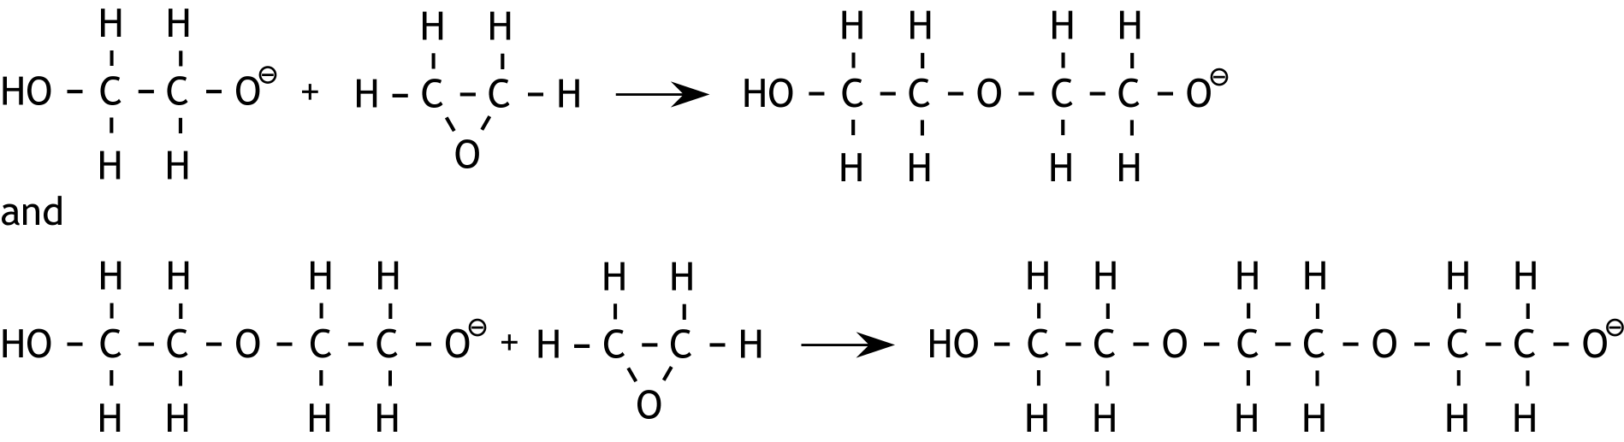
- Maximum score 3
A correct answer can be expressed as follows:

- correct structural formulas of ion A and of a molecule of epoxyethane before the arrow in the first reaction equation 1
- correct structural formula of the coupling product after the arrow in the first reaction 1
- correct coupling of the particle that is formed in the first reaction with a molecule of epoxyethane, depicted in structural formulas 1
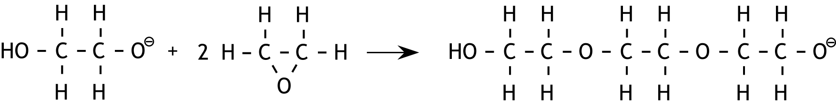
Note:
When the following answer is given, award full marks:

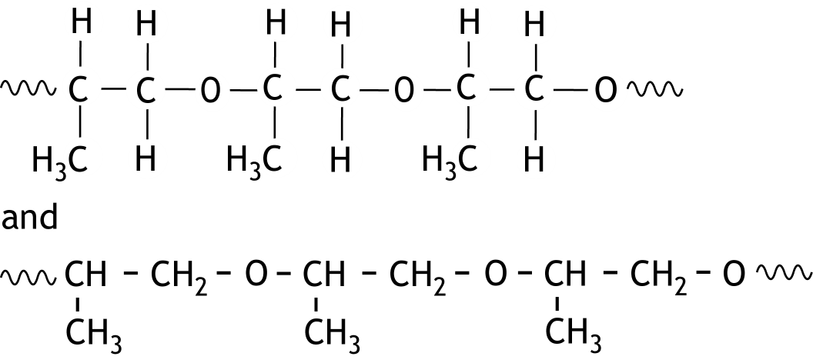
- Maximum score 3
Examples of a correct answer are:

- main chain correctly represented 1
- methyl groups correctly represented 1
- start and end of the fragment indicated with , − or • 1
If the following answer is given:
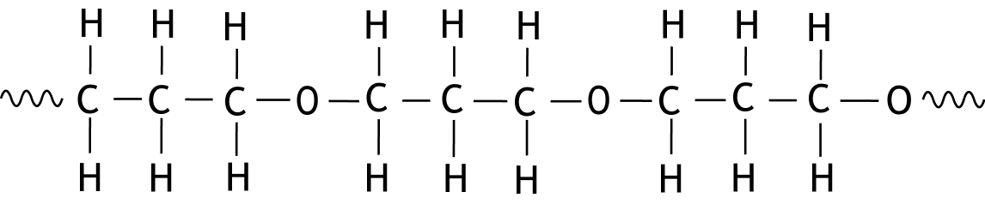
0

Note
When in contradiction to the above correct structural formula a 1,2-epoxypropane unit is 'reversed' linked, do not penalize.
- Maximum score 3
A correct answer can be expressed as follows:

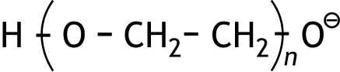
- before the arrow 1
- H₂O before the arrow 1
- correct formulas after the arrow 1
- Maximum score 4
An example of a correct calculation is:
mol epoxyethane reacts. And 92 − 88 g H₂O reacts, that is mol.
Therefore mol polyepoxyethane forms. Thus .
- calculation of the number of moles of epoxyethane that have reacted: divide 88 (g) by the molar mass of epoxyethane 1
- calculation of the number of grams of water that has reacted: 92 − 88 1
- calculation of the number of moles of polyepoxyethane that has been formed (is equal to the number of moles of water that have reacted): divide the number of grams of water by the molar mass of water 1
- calculation of n: divide the number of moles of epoxyethane that have reacted, by the number of moles of polyepoxyethane that has been formed 1
- Maximum score 3
An example of a correct answer is:
Polyepoxyethane with (on average) longer molecules has a higher melting range due to stronger van der Waals forces. The less water reacts, (the fewer termination reactions occur and) the longer the chains that are formed. So, in experiment 2 (with the smallest amount of water), polyepoxyethane with the highest melting range is formed.
- polyepoxyethane with longer molecules has a higher melting range because the van der Waals forces are stronger 1
- the less water reacts, the longer the molecules that are formed 1
- so: in experiment 2, polyepoxyethane with the highest melting range is formed 1
If an answer is given as: „With more water, more OH groups are formed, causing stronger molecular attachment through hydrogen bonds. Therefore, in experiment 1, polyepoxyethane with the highest melting range is formed.” 0

CHEMISTRY OLYMPIAD 2024

MARKING SCHEME PRELIMINARY ROUND 2

To be conducted from 19 until 22 March 2024

- This preliminary round consists of 20 multiple choice questions divided over 8 topics and 3 problems with a total of 15 open questions.
- The maximum score for this work is 95 points (no bonus points).
- Required materials: (graphic) calculator and BINAS 6th or 7th edition or ScienceData 1st edition or BINAS 5th edition, English version.
- For each question the number of points you can score are given.
- The attached marking scheme must be used when grading the work. In addition, the general rules for the Dutch Central Exams apply.

- Multiple-choice questions total 40 points

For every correct answer: 2 points
 |  | Carbon chemistry
1 | E | 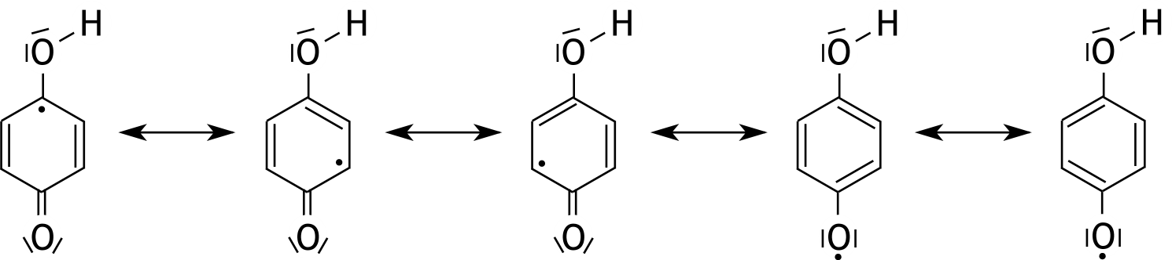
2 | A | Below the absolute configurations of both molecules are given.  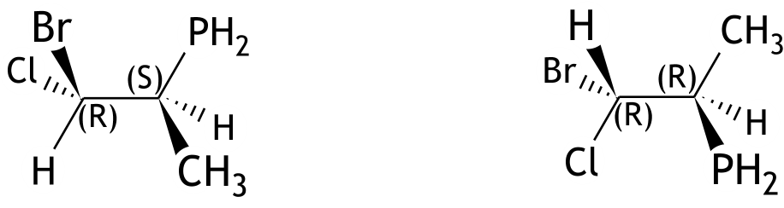  One stereocenter is different, so they are diastereomers.
3 | B | The five-membered ring with O and N contains a chiral C atom, indicated below with an asterisk. The P atom and the N atom are not chiral.  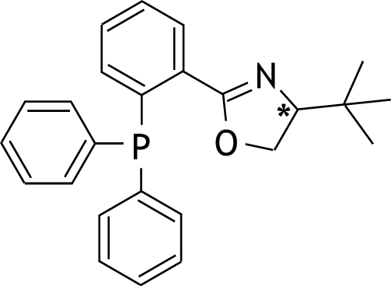
 |  | Reaction rate and equilibrium
4 | C | The second step determines the rate, for which the following applies: s = k[HOOBr][HBr].  The equilibrium constant expression of step 1 is .  So [HOOBr] = K[O₂ ][HBr].  The rate expression becomes s = kK[O₂][HBr][HBr] = k' [O₂][HBr]².

 | 5 | B |  | The following applies:  and  p_{X} + p_{Y} + p_{Z} = p and p_{Y} = p_{Z}  so  and
 |  |  |  | Structures and formulas
 | 6 | F |  | In the molecule Cl – N = C = O, the N atom also has a non-bonding electron pair. N therefore has 3 electron domains and ∠ ClNC will be (approximately) 120º.  C has 2 electron domains and ∠ NCO is therefore 180º.
 | 7 | C |  | The electron configuration of ₃₂Ge in the ground state is  1s² 2s² 2p⁶ 3s² 3p⁶ 3d¹⁰ 4s² 4p².  The set of quantum numbers n = 4 , l = 1 , m_{l} = 1 , m_{s} = + ½ corresponds to an electron in a 4p orbital.  The first three quantum numbers at C indicate that this electron would be in the same 4p orbital as the mentioned electron. This is not possible because the second electron must be in a different 4p orbital  A corresponds to an electron in a 3d orbital.  B corresponds to an electron in the 4s orbital.  D corresponds to the second electron in the 4p level, which is in another 4p orbital.
 | 8 | E |  | The bond between the two C atoms is a σ-bond and each of the triple bonds consists of one σ-bond and two π-bonds.
 |  |  |  | pH / acid-base
 | 9 | B |  | The graph shows a titration of a weak base with a strong acid (the initial pH is higher than 7 and the pH at the equivalence point is lower than 7).
 | 10 | B |  | The following reaction occurs: H₂PO₄‒ + OH‒ → HPO₄^{2‒} + H₂O.  For the buffer solution that is created:  pH = pK_{a} ‒ log or 6.90 = 7.21 ‒ log  log = 7.21 ‒ 6.90 = 0.31 or = 10^{0.31} = 2.0.  Suppose that a mL of 1.0 M NaOH solution was added,  then = 2.0; solving this equation gives a = 33 (mL).
 |  |  |  | Redox and electrochemistry
 | 11 | F |  | Zn²⁺ is a stronger oxidising agent than H₂O. Zn is a stronger reducing agent than H₂O.
 | 12 | D |  | In the Nernst equation for half-reaction I [H⁺] is present, and in the Nernst equation for half-reaction II [OH‒] is present. Both concentrations are determined by the pH of the solution.
 | 13 | D |  | The half-reaction at the negative electrode can be represented as:  CO₂ + 6 H⁺ + 6 e— → CH₃OH + H₂O.  The maximum amount that can be formed is: .  So of the current is used for the conversion of CO₂ into CH₃OH.
 |  |  |  | Analysis
 | 14 | A |  | Al³⁺ and SO₄^{2‒} are both oxidising agents. (I‒, H₂C₂O₄ and Sn²⁺ are reducing agents and can be oxidised by dichromate, forming Cr³⁺.)
 | 15 | D |  | In the resulting solution, mol L^{‒1}.  The volume of the resulting solution is 100.0 mL.  So, 50.0 × 3.00·10^{‒4} ‒ 100.0 × 5.00·10^{‒5} = 1.00·10^{‒2} mmol MnO₄‒ was converted.  This has reacted with mmol SO₃^{2‒}.  Therefore, the molarity of the sodium sulphite solution was mol L^{‒1}.
 |  |  | Chemical calculations
16 |  | C |  | 900 °C is 1173 K, 2.00 atm is 2.02·10⁵ Pa and 0.826 g dm^{—3} is 0.826·10³ g m^{—3}.  Let the molar mass be M g mol^{—1}, then 1.00 m³ of the gas contains moles.  According to the ideal gas law, pV = nRT or 2.02·10⁵ × 1.00 = × 8.314 × 1173 or .  That is the molar mass of Ar.

17 | C | Part of the Zn has been converted into Zn(OH)₂ in the block . The extra mass is all  OH—: 140.2 g — 113.0 g = 27.2 g OH—, and that is mol OH—. That corresponds to moles of Zn²⁺ and that much Zn(0) has also been converted.  There were originally moles of Zn(0); in the final block the amount of Zn(0) is therefore 1.728 — 0.800 = 0.928 mol Zn(0).  The ratio Zn(0) : Zn(II) is therefore 0.928 : 0.800 = 1.16 : 1.00.
 |  | Thermochemistry and Green Chemistry
18 | D | E-factor =  If the percentage yield is η, then:  .  This results in η = 0.68, so the percentage yield is 68%.
19 | D | 2 H₂S + 3O₂ → 2 SO₂ + 2 H₂O  CS₂ + 2 H₂O → 2 H₂S + CO₂  2 H₂S + 3 O₂ + CS₂ + 2 H₂O → 2 SO₂ + 2 H₂O + 2 H₂S + CO₂  So ∆_{r}H₃ = 2 × ∆_{r}H⁰₁ ‒ ∆_{r}H⁰₂ = 2 × (‒ 518.2) ‒ 67.8 = ‒ 1104.2 kJ mol^{‒1}.
20 | B | ΔG⁰ = ΔH⁰ − TΔS⁰  At B, 2 moles of gas are formed from 2 moles of gas. In the other reactions the amount of moles of gas increases. So for B, ΔS⁰ will be much closer to zero than for the other reactions.

Open questions total 55 points
- Hydrogen for a fuel cell 15 points
- Maximum score 3
An example of a correct calculation is:
- conversion from 0.100 dm³ H₂ to moles: divide 0.100 (dm³) by 24.5 (dm³ mol⁻¹) 1
- calculation of the amount of moles of Ru: divide the amount of moles of H₂ by 92 (mol mol⁻¹) 1
- conversion from the amount of moles of Ru to mg: multiply the amount of moles of Ru by 101.1 (g mol⁻¹) and by 10³ (mg g⁻¹) 1
- Maximum score 4
An example of a correct calculation is:
(1.0 × 0.100) × 4 × 24.5 : 0.100 = 98 (min)
- calculation of the amount of moles of NaBH₄: multiply 1.0 (mol L⁻¹) by 0.100 (L) 1
- calculation of the amount of moles of H₂: multiply the amount of moles of NaBH₄ by 4 1
- conversion from moles of H₂ to dm³: multiply the amount of moles of H₂ by 24.5 (dm³ mol⁻¹) 1
- calculation of the amount of minutes: divide the amount of dm³ of H₂ by 0.100 (dm³ min⁻¹) 1
Note
When in the answer to question 1 a wrong value is used for V_{m} and in the answer to question 2 that same wrong value is used for V_{m}, do not penalize this again.
- Maximum score 4
An example of a correct calculation is:
(At the temperature T that is needed, applies that:)
k_{T} = 2 × k₂₉₈
- Arrhenius equation was written down and potentially filled in (partially) 1
- notion that by the temperature used for the calculation, T, applies that k_{T} = 2 × k₂₉₈ 1
- Arrhenius equation filled in (almost complete) 1
- calculation of temperature needed 1
- Maximum score 4
An example of a correct calculation is:
ΔE⁰ = E⁰_{ox} − E⁰_{red} = + 0.40 − ( − 0.83) = + 1.23 V
ΔG⁰ = − nFΔE⁰ = − 2 × 9.649·10⁴ × 1.23 = − 2.37·10 ⁵ J (mol⁻¹ H₂O)
- calculation of ΔE⁰ 1
- notion that n = 2 mol e⁻ per mol of H₂O 1
- rest of the calculation correct 1
- correct unit of ΔG⁰ 1
- A high-temperature superconductor 24 points
- Maximum score 3
2 Y₂(CO₃)₃ + 8 BaCO₃ + 12 CuCO₃ + (1 − 2x) O₂ → 4 YBa₂Cu₃O_{(7 − x)} + 26 CO₂
- all formulas before and after the arrow are correct 1
- correct coefficients for Y₂(CO₃)₂, BaCO₃, CuCO₃, YBa₂Cu₃O_{(7 − x)} and CO₂ 1
- correct coefficient for O₂ 1
Note
If the following equation is given:
Y₂(CO₃)₃ + 4 BaCO₃ + 6 CuCO₃ + ½(1 − 2x) O₂ → 2 YBa₂Cu₃O_{(7 − x)} + 13 CO₂
accept it as correct.
- Maximum score 4
An example of a correct answer:
Per mol YBCO, 0.20 × 3 = 0.60 mol Cu³⁺ is formed, and 3 − 0.60 = 2.40 mol Cu²⁺ remains.
The total amount of positive charges is 3 + 2 × 2 + 2.40 × 2 + 0.60 × 3 = 13.6.
This should be equal to the total amount of negative charges: (7 − x) × 2.
From this follows that x = 0.20.
- calculation of the amount of moles of Cu³⁺ that is produced 1
- calculation of the amount of moles of Cu²⁺ that remains 1
- calculation of the total amount of moles of positive and negative charges 1
- calculation of x 1
- Maximum score 2
Cu³⁺ + e⁻ → Cu²⁺ × 4
2 H₂O → O₂ + 4 H⁺ + 4 e⁻ × 1
4 Cu³⁺ + 2 H₂O → 4 Cu²⁺ + O₂ + 4 H⁺
- the equations of both half-reactions are correct 1
- correct combination of the equations of both half-reactions 1
- Maximum score 7
An example of a correct calculation is:
21.8 mL 0.0332 M sodium thiosulfate solution contains 21.8 × 0.0332 mmol S₂O₃²⁻.
This has reacted with mmol I₂, so the iodide has reacted with mmol Cu²⁺.
This is the total amount of Cu²⁺ and Cu³⁺ in the 160 mg YBa₂Cu₃O_{(7 − x)},
therefore 160 mg YBa₂Cu₃O_{(7 − x)} is mmol.
The molar mass of YBa₂Cu₃O_{(7 − x)} is {554.2 + (7 − x) × 16.00} g mol⁻¹, therefore 160 mg is mmol.
Thus = . Consequently x = 0.19.
- calculation of the amount of mmoles of S₂O₃²⁻: multiply 21.8 (mL) by 0.0332 (mmol mL⁻¹) 1
- calculation of the amount of mmoles of iodide that reacted: divide the amount of mmoles of S₂O₃²⁻ by 2 1
- calculation of the amount of mmoles of Cu²⁺ that reacted: multiply the amount of mmoles of iodide that reacted by 2 1
- calculation of the amount of mmoles of YBa₂Cu₃O_{(7 − x)} that follows from that: divide the amount of mmoles of Cu²⁺ that reacted by 3 1
- calculation of the molar mass of YBa₂Cu₃O_{(7 − x)}: 554.2 + (7 − x) × 16.00 (mg mmol⁻¹) 1
- calculation of the amount of mmoles of YBa₂Cu₃O_{(7 − x)} in 160 mg: divide 160 (mg) by the molar mass of YBa₂Cu₃O_{(7 − x)} (in mg mmol⁻¹) 1
- rest of the calculation 1
- Maximum score 4
Examples of a correct answer are:
Suppose there are p oxide ions on the edges and q on exterior faces, then p + q = 20 and .
Solving this system of two equations with two unknowns yields p = 12 en q = 8.
- notion that oxide ions on the edges contribute one fourth each 1
- notion that oxide ions in the exterior faces count for one half each 1
- setting up two equations with two unknowns 1
- solving the system of two equations with two unknowns 1
and
Suppose there are p oxide ions on the edges, then there are 20 − p oxide ions on exterior faces. It follows that
.
This results in p = 12. Therefore, there are 12 oxide ions on the edges and 8 on exterior faces.
- notion that oxide ions on the edges count for one fourth each 1
- notion that oxide ions on the exterior faces count for one half each 1
- thus 1
- rest of the calculation 1
If, without calculation or explanation, the answer „There are 12 oxide ions on the edges and 8 oxide ions on exterior faces.” is given 0
- Maximum score 4
An example of a correct answer is:
The mass of the unit cell is 666.2 u; the volume of the unit cell is 0.382 × 0.389 × 1.168 nm³.
Therefore the density is: .
- calculation of the mass of the unit cell in u 1
- calculation of the volume of the unit cell in nm³ 1
- calculation of the density in u nm⁻³ 1
- conversion of the density in u nm⁻³ into g cm⁻³ 1
Note
When the same mistake is made in the calculation of the unit cell mass as in the calculation of the molar mass of YBa₂Cu₃O_{(7 − x)} in question 8, do not penalize this again.

- Penicillin 16 points
- Maximum score 2
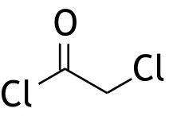
A correct answer may look as follows:

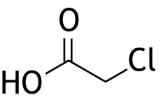
If the answer is given 1
- Maximum score 4
A correct answer may look as follows:
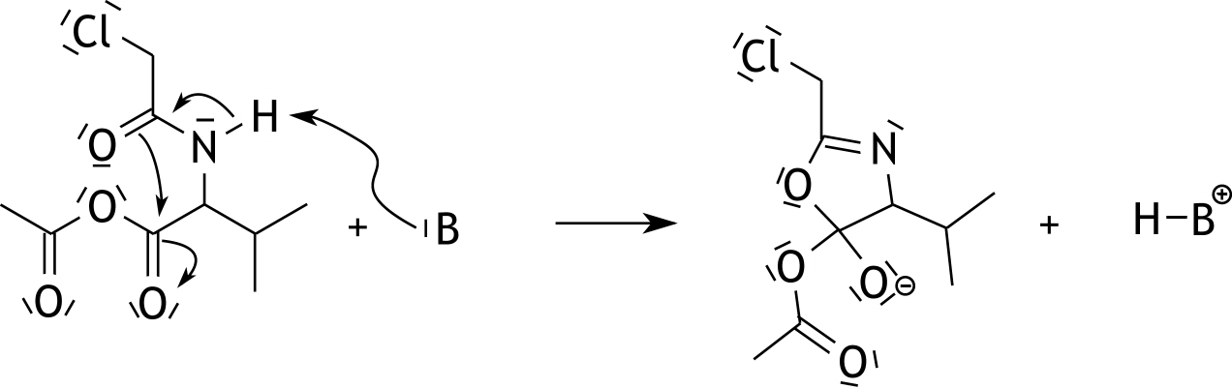

- H − B⁺ after the arrow 1
- the shift of electron pairs before the arrow is correctly shown 1
- non-bonding electron pairs before and after the arrow correctly shown 1
- correct structural formula including formal charges of the product after the arrow 1
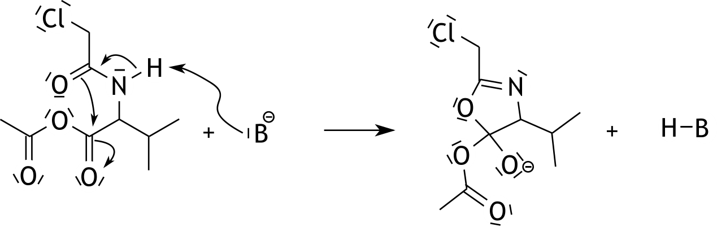
Note
If the following answer is given:

mark this as being correct.
- Maximum score 3
A correct answer may look as follows:
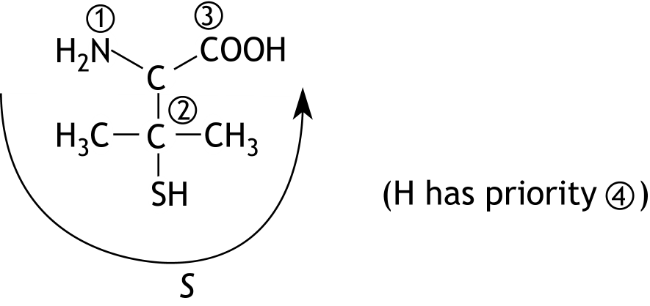

- a correct drawing 1
- correct prioritization 1
- correct indication of the configuration 1
- Maximum score 4
A correct answer may look as follows:
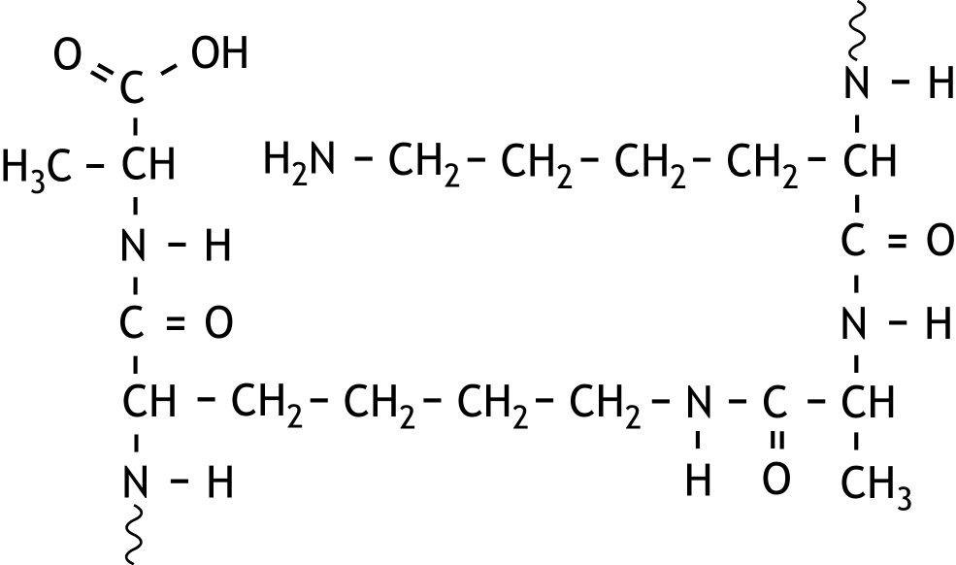

- beginning and end of the structural formula shown with 1
- the terminal alanine group correctly shown 1
- the peptide bonds correctly shown 1
- the rest groups correctly shown 1
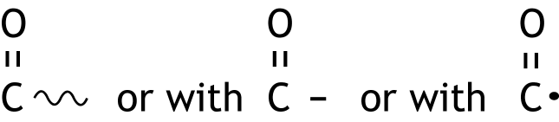
If in an otherwise correct answer the beginning and/or end of the structural formula is
shown with 3
- Maximum score 3
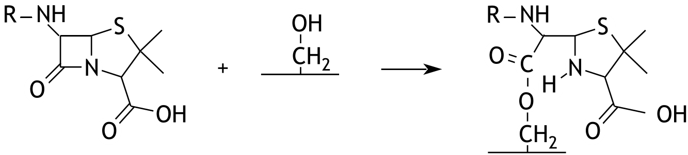
A correct answer may look as follows:

- the peptide bond in the four-membered ring is broken 1
- the formed ester bond correctly shown 1
- the formed NH group correctly shown 1

45e National Chemistry Olympiad

Maastricht University

THEORY TEST

Marking scheme

Wednesday June 5 2024

- This test consists of 7 problems with 32 open questions and an answer sheet.
- The maximum score fort his test is 120 points.
- The test will last a maximum of 4 clock hours.
- Required resources: (graphic) calculator and BINAS 6th of 7th edition or BINAS 5th edition, English version or ScienceData 1st edition.
- For each question the number of points you can score are given.

- NF 12 points
- Maximum score 7
A correct answer can look as follows:
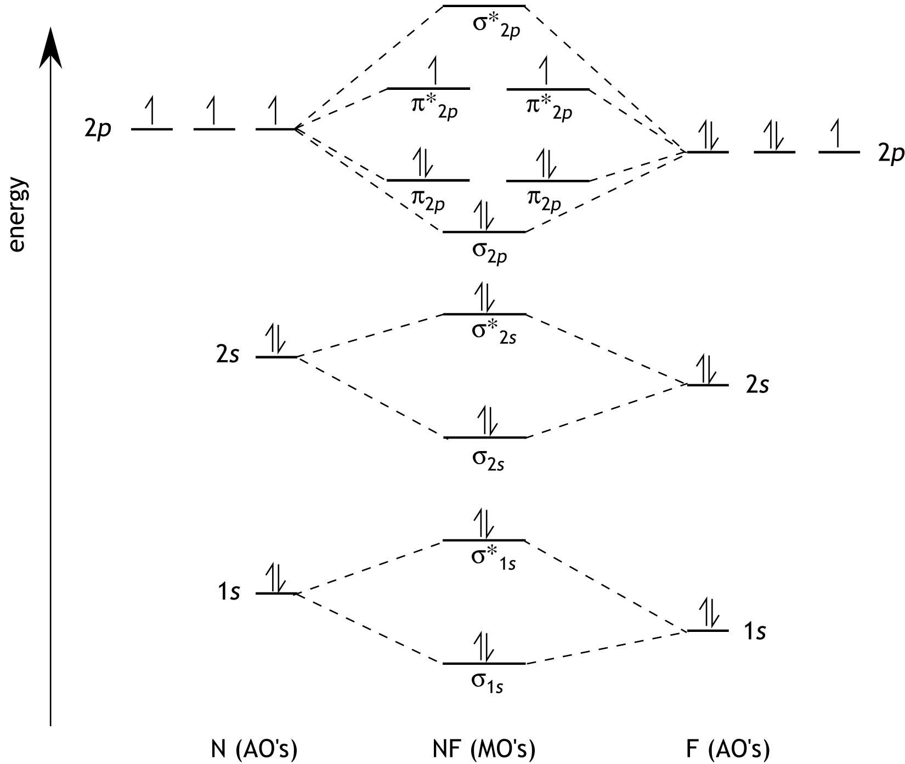

- the energy levels of the fluorine atom are drawn lower than the energy levels of the nitrogen atom 1
- one electron pair in the 1s and 2s levels of the nitrogen atom and the oxygen atom 1
- three unpaired electrons the 2p level of the nitrogen atom 1
- two electron pairs and one unpaired electron in the 2p level of the fluorine atom 1
- the levels of all molecular orbitals are correctly represented with the correct notations 1
- electron pairs in σ_{1s}, σ*_{1s}, σ_{2s}, σ*_{2s} and in σ_{2p} and in both π_{2p}’s of the nitrogen monofluoride molecule 1
- in each π*_{2p} of the nitrogen monofluoride molecule an unpaired electron 1
If in an otherwise correct answer the unpaired electrons in the 2p level of the nitrogen atom and/or the unpaired electrons in the π*_{2p} levels of the nitrogen monofluoride molecule are not parallel drawn 6
- Maximum score 2
An example of a correct answer is:
There are ten electrons in BMO’s and six electrons in ABMO’s, so .
- ten electrons in BMO’s and six electrons in ABMO’s 1
- rest of the calculation 1
Notes
- When an incorrect answer to question 2 is consequently due to an incorrect answer to question 1, accept this answer to question 2 as correct.
- When the answer is given,accept this as correct.
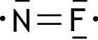
- Maximum score 3
A correct answer can be shown as follows:

- double bond 1
- double radical 1
- rest of the structure 1
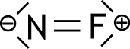
If the answer to question 1 is correct and here the answer is given 2
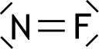
If the answer to question 1 is correct and here the answer is given 1
Note
When an incorrect answer to question 3 is consequently due to an incorrect answer to question 1 and/or question 2, accept this answer to question 3 as correct.
- Dinitrogen pentoxide 19 points
- Maximum score 3
A correct Lewis structure can be represented as follows:
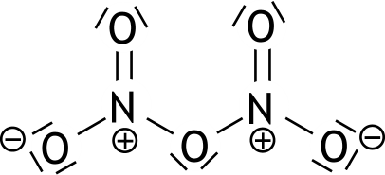

- single bonds and double bonds between the N atoms and O atoms correct 1
- lone pairs correct 1
- formal charges correct 1
- Maximum score 3
A correct answer can be formulated as follows:
Each N atom with the attached O atoms lie in one plane. There is free rotation around the bonds between the central O atom and the N atoms. So it is possible that all seven atoms lie in one plane.
- each N atom with the attached O atoms lie in one plane 1
- there is free rotation around the bonds between the central O atom and the N atoms 1
- correct conclusion 1
- Maximum score 3
An example of a correct answer is:
(By multiplying the first and third reaction equation by two and adding these to the second reaction equation, one obtains 2 N₂(g) + 5 O₂(g) → 2 N₂O₅(g):)
2 × (− 116.2) + (− 106.2) + 2 × (+ 182.6) = (+) 26.6 kJ per 2 moles of N₂O₅
Δ_{f}H⁰ of N₂O₅ = (+) 26.6 : 2 = (+) 13.3 (kJ mol⁻¹)
- Δ_{r}H⁰_{1,} Δ_{r}H⁰₂ and Δ_{r}H⁰₃ are used in the summation 1
- multiplication factors are correctly used in the summation 1
- rest of the calculation is correct 1
- Maximum score 5
An example of a correct calculation is:
ΔG = ΔH – TΔS = + 94.83∙10³ – 600 × (269 + 293 – 426) = (+) 13.23∙10³ (J mol⁻¹)
ΔG = – RT ln K_{p}
- calculation of ΔS 1
- calculation of ΔG 1
- ΔG = – RT ln K_{p}, possibly already partly completed 1
- calculation of ln K_{p} 1
- calculation of K_{p} 1
- Maximum score 5
An example of a correct calculation is:
, because the pressure is given in bar, this can be written as .
In the equilibrium are (1 − x) moles of N₂O₅, x moles of NO₂, x moles of NO₃ present per original mole of N₂O₅. So there are in total (1 + x) moles of gas present.
Solving this equation yields x = 0.64 (mol).
- 1
- in the equilibrium (1 − x) moles of N₂O₅, x moles of NO₂ and x moles of NO₃ are present, so (1 + x) moles of gas in total 1
- 1
- , possibly already partly completed 1
- solving of the equation 1
Note
When an incorrect answer to question 8 is consequently due to an incorrect answer to question 7, accept this answer to question 8 as correct.
- Chromium 21 points
- Maximum score 4
4 Cr₂O₃.FeO + 8 Na₂CO₃ + 7 O₂ → 8 Na₂CrO₄ + 2 Fe₂O₃ + 8 CO₂
- all formulas correct and at the correct side of the reaction arrow 1
- chromium balance and iron balance correct 1
- sodium balance and carbon balance correct 1
- the oxygen balance correct 1
- Maximum score 3
Add water (and heat or stir). Filter the resulting mixture and evaporate the filtrate.
- add water (and heat or stir) 1
- filtrate 1
- evaporate 1
- Maximum score 3
2 H⁺ + 2 CrO₄^{2—} → Cr₂O₇^{2—} + H₂O of 2 H₃O⁺ + 2 CrO₄^{2—} → Cr₂O₇^{2—} + 3 H₂O
- H⁺ (or H₃O⁺) and CrO₄^{2—} before the arrow 1
- Cr₂O₇^{2—} and H₂O after the arrow 1
- correct coefficients 1
- Maximum score 4
In the conversion of Cr₂O₇^{2—} to Cr, 12 moles of electrons per mole of Cr₂O₇^{2—} are involved.
In the conversion of Cr₂O₇^{2—} to Cr³⁺, 6 moles of electrons per mole of Cr₂O₇^{2—} are involved.
So, in the conversion of 100 moles of Cr₂O₇^{2—}, totally 95.0 × 12 + 5.0 × 6 moles of electrons are involved.
So, the percentage of the electron current that is used for the conversion to Cr is .
- notion that in the conversion of Cr₂O₇^{2—} to Cr, 12 moles of electrons per mole of Cr₂O₇^{2—} are involved 1
- notion that in the conversion of Cr₂O₇^{2—} to Cr³⁺, 6 moles of electrons per mole of Cr₂O₇^{2—} are involved 1
- calculation of the total amount of electrons that is involved in the conversion of 100 moles of Cr₂O₇^{2—} 1
- rest of the calculation 1
- Maximum score 7
An example of a correct calculation is:
The density of chromium is and that is in good agreement with the value of 7.15·10³ kg m^{—3} that is listed Binas/ScienceData.
- notion that there are two atoms in a bcc unit cell 1
- calculation of the mass of the unit cell in u 1
- calculation of the mass of the unit cell in kg 1
- notion that the length of the body diagonal is four times the atomic radius 1
- calculation of the length of the edge of the unit cell 1
- calculation of the volume of the unit cell 1
- calculation of the density and conclusion 1

- Methyl isocyanide 15 points
- Maximum score 7
An example of a correct answer is:
For the steady state approximation applies:
CH₃NC* is created in the forward reaction of equilibrium (1) and is converted in the backward reaction of equilibrium (1) as well as in reaction (2). For this applies respectively , and .
So .
From this it follows that .
So, for the formation of CH₃CN applies .
- 1
- 1
- 1
- notion that [CH₃NC*] does not change in time 1
- 1
- 1
- 1
- Maximum score 2
For the overall reaction it applies that , if we combine this with the given rate equation, we get .
- notion that for the overall reaction applies 1
- correct expression for k_{exp} 1
- Maximum score 2
An example of a correct answer is:
For the backward reaction in equilibrium (1) two molecules have to collide, while in reaction (2) only one molecule reacts. So the backward reaction in equilibrium (1) is more favored when the pressure is increased. So s_{—1} becomes higher than s₂ at high pressure and lower than s₂ at low pressure.
- mentioning that s_{—1} is dependent of two species and s₂ of one 1
- rest of the explanation 1
- Maximum score 4
An example of a correct answer is::
When at high pressure s_{—1} >> s₂, then k_{—1}[CH₃NC] >> k₂. In that case k₂ can be neglected to
k_{—1}[CH₃NC]. For the rate equation applies then and that is first order in [CH₃NC].
When at low pressure s_{—1} << s₂, then k_{—1}[CH₃NC] << k₂. In that case k_{—1}[CH₃NC] can be neglected to k₂. For the rate equation applies then and that is second order in [CH₃NC].
- notion that at high pressure k_{—1}[CH₃NC] >> k₂ 1
- rest of the explanation for high pressure 1
- notion that at low pressure k_{—1}[CH₃NC] << k₂ 1
- rest of the explanation for low pressure 1
- Electrochemical cell 15 points
- Maximum score 3
To half-cell I applies .
To half-cell II applies .
So EMF = V_{I} — V_{II} = 0.75 — 0.32 = 0.43 V.
- calculation of V_{I} 1
- calculation of V_{II} 1
- calculation of V_{bron} 1
If the answer is given 2
- Maximum score 6
Let it take t seconds, that is 0.200 × t C and this corresponds to moles of electrons.
On the silver electrode moles of Ag are formed, that is g.
So, the mass of the silver electrode becomes g.
From the copper electrode moles of Cu are dissolved, that is g.
So, the mass of the copper electrode is g.
From = it follows that t = 5.18·10⁴ s.
- calculation of the number of C 1
- calculation of the number of moles of electrons 1
- calculation of the number of moles of Ag that are formed and of the number of moles of Cu that are dissolved 1
- calculation of the number of grams of Ag that are formed and of the number of grams of Cu that are dissolved 1
- calculation of the masses of both electrodes 1
- calculation of t 1
- Maximum score 6
A correct answer can be formulated as follows:
When a solution of sodium carbonate is added to half-cell I, a precipitate of silver carbonate is formed. In half-cell I [Ag⁺] becomes lower and so does V_{I} and (because V_{II} does not change) the EMF becomes smaller.
When a solution of sodium carbonate is added to half-cell II, a precipitate of copper carbonate is formed. In half-cell II [Cu²⁺] becomes lower and so does V_{II} and (because V_{I} does not change) the EMF becomes higher.
When a solution of sodium chloride is added to half-cell II (no reaction takes place, but) the solution is diluted, so [Cu²⁺] becomes lower and so does V_{II} and (because V_{I} does not change) the EMF becomes higher.
- correct explanation that V_{I} becomes lower on adding a solution of sodium carbonate to half-cell I 1
- correct conclusion regarding the effect on the EMF on adding a solution of sodium carbonate to half-cell I 1
- correct explanation that V_{II} becomes lower on adding a solution of sodium carbonate to half-cell II 1
- correct conclusion regarding the effect on the EMF on adding a solution of sodium carbonate to half-cell II 1
- correct explanation that V_{II} becomes lower on adding a solution of sodium chloride to half-cell II 1
- correct conclusion regarding the effect on the EMF on adding a solution of sodium chloride to half-cell II 1

- Barbituric acid 13 points
- Maximum score 3
A correct answer can be formulated as follows:
In point A / at 221 nm applies that the absorbance of 1 M HZ solution is equal to the absorbance of 1 M Z⁻ solution. Because [HZ] + [Z⁻] equals 1.00 mol L⁻¹ the graph corresponding to pH 3.60 also passes through A.
- (in point A / at 221 nm applies that) the absorbance of 1 M HZ solution is equal to the absorbance of 1 M Z⁻ solution 1
- [HZ] + [Z⁻] equals 1.00 mol L⁻¹ 1
- correct conclusion 1
or
Because [HZ] = [Z⁻] (= 1.00 mol L⁻¹) and , in punt A / at 221 nm the molar absorptivity of HZ equals the molar absorptivity of Z⁻. So the graph corresponding to pH 3.60 also passes through A.
- (in point A / at 221 nm) 1
- correct explanation why (in point A / at 221 nm) 1
- correct conclusion 1
If an answer is given like: „[HZ] + [Z⁻] at pH=3.60 equals [HZ] at pH = 2.00, so the graph corresponding to pH 3.60 also passes through A.” 1
If one of the following answers is given:
„At 221 nm and at pH=3.60 [HZ] equals [Z⁻], so the graph corresponding to pH 3.60 also passes through A.”
or
„HZ and Z⁻ induce both, apart from each other, an absorbance, so the absorbance at 221 nm in the graph corresponding to pH = 3.60 doubles the absorbance of point A.” 0
If only a conclusion is given 0
- Maximum score 2
At pH = 2.00: A = 1.0⋅10³
At pH = 3.60: A = 8.0⋅10³
At pH = 7.20: A = 23.0⋅10³
If only two readings are correct 1
If only one reading is correct 0
Notes
- The readings may deviate maximum 0.1⋅10³ from the above mentioned readings.
- When instead of 1.0⋅10³, 8.0⋅10³ and 23.0⋅10³ the readings 1⋅10³, 8⋅10³ and 23⋅10³ are given, do not penalize.
- Maximum score 5
An example of a correct calculation is:
Let [Z⁻] = a (mol L⁻¹), then [HZ] = (1 − a) (mol L⁻¹)
Then applies: a × 23⋅10³ + (1 − a) × 1,0⋅10³ = 8,0⋅10³
Solving this equation yields: a = 0.32 mol L⁻¹= [Z⁻].
So [Z⁻] : [HZ] = 0.32 : 0.68.
- taking [Z⁻] = a (mol L⁻¹) and [HZ] = (1 − a) (mol L⁻¹) 1
- notion that = a × 23⋅10³ and = (1 − a) × 1.0⋅10³ 1
- formulating the equation a × 23⋅10³ + (1 − a) × 1.0⋅10³ = 8.0⋅10³ 1
- solving of a from the equation 1
- calculation of the ratio [Z⁻] : [HZ] = a : (1 − a) 1
When an incorrect answer to question 23 is consequently due to an incorrect answer to question 22, accept this answer to question 23 as correct.
- Maximum score 3
An example of a correct calculation is:
- , eventually already filled in partially 1
- calculation of [H⁺] = 10^{−3.60} from pH = 3.60 1
- calculation of K_{a} from the calculated [H⁺] and the calculated ratio [Z⁻] : [HZ] 1
If the calculation is given 2
Note
When an incorrect answer to question 24 is a direct consequence of an incorrect answer to question 23, do not penalize.
- Melphalan 25 points
- Maximum score 4
An example of a correct answer is:
Number 2 (is the steric centre).
The priority order is:
1: NH₂; 2: COOH; 3: CH₂; 4: H.
(With H facing backwards) 1-2-3 turns counterclockwise, so the S-configuration.
- (steric centre is C) number 2 1
- correct priority 1
- explanation how to look at the surroundings of the steric centre 1
- correct conclusion 1
- Maximum score 4
chemical shift  (ppm) | multiplicity | integral | number(s) of the C atom(s)
2.8 | doublet | 2 H | 3
3.5 | triplet | 4 H | 10, 12
3.6 | triplet | 1 H | 2
3.9 | triplet | 4 H | 11, 13
6.7 | doublet | 2 H | 6, 8
6.8 | doublet | 2 H | 5, 9
- only number 3 at 2.8 ppm are filled in correctly 1
- only number 2 at 3.6 ppm are filled in correctly 1
- only the numbers 10 and 12 at 3.5 ppm are filled in correctly and only the numbers 11 and 13 at 3.9 ppm are filled in correctly 1
- only the numbers 6 and 8 at 6.7 ppm are filled in correctly and only the numbers 5 and 9 at 6.8 ppm are filled in correctly 1
Notes
- The numbers 10 and 12 may be interchanged with the numbers 11 and 13.
- The numbers 6 and 8 may be interchanged with the numbers 5 and 9.
- Maximum score 2
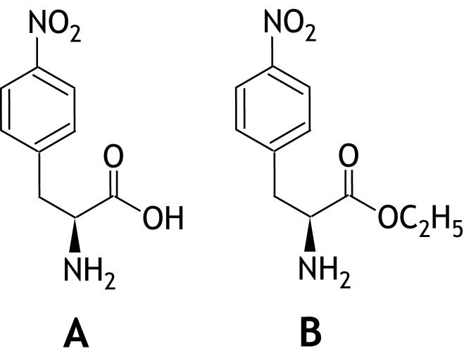

- A correct 1
- B correct 1

- Maximum score 2
A correct answer can be formulated as follows:
(Nitration of an aromatic ring is an electrophilic substitution.) The group that is present already at the aromatic ring, apparently is a para-director. Such a group cannot be a meta-director at the same time (but it can be an ortho-director).
- the group that is present already at the aromatic ring, apparently is a para-director 1
- para-directing effect and meta-directing effect cannot happen together 1
If only an answer has been given as: „The group that is present already at the aromatic ring, is an ortho-para-director.” 1
- Maximum score 2
A correct answer can be formulated as follows:
(The substitution at the para-position can take place unhindered.) The substitution at the ortho-positions is steric hindered by the bulky group at the aromatic ring.
- there already is a bulky group at the aromatic ring 1
- substitution at the ortho-positions is steric hindered by that group 1
- Maximum score 5
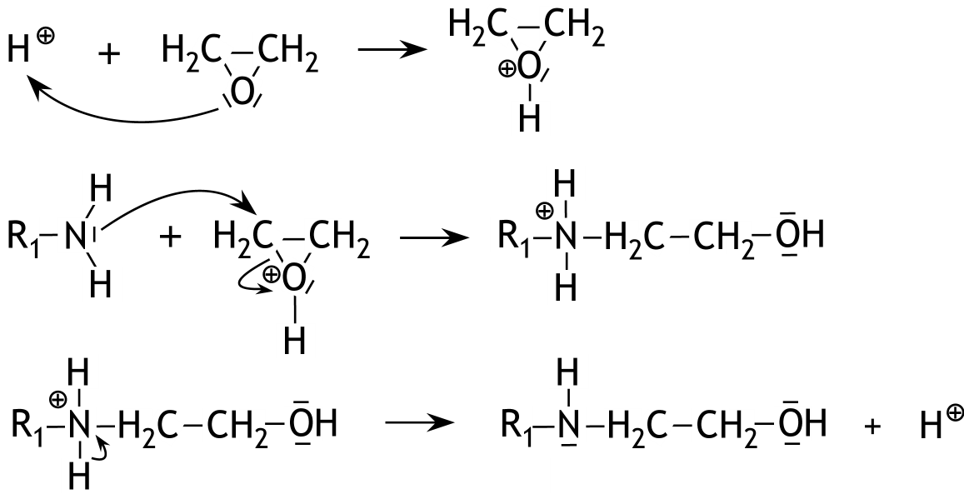
A correct answer can be given as follows:

- the structures of the intermediates correctly drawn 1
- the structure of the product correctly drawn 1
- the lone pairs correctly drawn 1
- the curly arrows correctly drawn 1
- the formal charges correctly placed 1
- Maximum score 2
A correct answer can be formulated as follows:
In step 4 (only) the nitro group is hydrogenated. The C = O group(s) is (are) not hydrogenated.
- the nitro group is hydrogenated 1
- the C = O group(s) is (are) not hydrogenated 1
Note
When an answer has been given as: „In step 4 (only) the nitro group is hydrogenated. The aromatic ring(s) is (are) not hydrogenated.”, give full marks.
- Maximum score 4
A correct answer can be formulated as follows:
In step 2 a protection is introduced, that is removed in step 7.
The reason for this protection is to prevent the COOH group reacting in step 3 / in step 4 / in step 5 / in step 6 (too).
In step 3 a protection is introduced, that is removed in step 7.
The reason for this protection is to prevent the NH₂ group reacting in step 5 (too).
- introduction and removal of the first protection correctly indicated 1
- correct reason for the first protection 1
- introduction and removal of the second protection correctly indicated 1
- correct reason for the second protection 1

45th National Chemistry Olympiad

Maastricht University

PRACTICAL TEST

Marking scheme

Thursday June 6, 2024

- The determination of the amount of crystal water (x) in a mixture of Na₂CO₃.xH₂O and NaHCO₃ 40 points
Maximum score 10
The following practical skills are assessed:
- safety, working clean and independence
- handling of the glassware
- Maximum score 8
- mass of the sample and the molarity of the hydrochloric acid 1
- burette readings read in two decimals 2
- difference between the two duplicates of the titrations 5
The score points for the differences between the two duplicates for each titration are determined as follows:
If the difference in the used volume between the duplicates ≤ 0.10 mL 5
If 0.10 mL < the difference in the used volume between the duplicates ≤ 0.20 mL 4
If 0.20 mL < the difference in the used volume between the duplicates ≤ 0.30 mL 3
If 0.30 mL < the difference in the used volume between the duplicates ≤ 0.50 mL 2
If 0.50 mL < the difference in the used volume between the duplicates ≤ 0.70 mL 1
If the difference in the used volume between the duplicates > 0.70 mL 0
The final score is the average of the scores for both titrations.
- Maximum score 4
Titration with phenolphthalein:
CO₃²⁻ + H₃O⁺ → HCO₃⁻ + H₂O
Titration with methyl orange:
CO₃²⁻ + 2 H₃O⁺ → CO₂ + 3 H₂O and HCO₃⁻ + H₃O⁺ → CO₂ + 2 H₂O
- correct reaction equation for the titration with phenolphthalein 1
- for the titration with methyl orange, correct reaction equation with the carbonate 2
- for the titration with methyl orange, correct reaction equation with the hydrogen carbonate 1
Notes
- When H⁺ is used instead of H₃O⁺, in an otherwise correct equation, accept this as correct.
- When for the titration with methyl orange the equations
CO₃²⁻ + H₃O⁺ → HCO₃⁻ + H₂O and HCO₃⁻ + H₃O⁺ → CO₂ + 2 H₂O are given, accept this as correct.
- When H₂CO₃ is written after the arrow in the equations for the titration with methyl orange, do not penalize this.
- Maximum score 10
From the titration with phenolphthalein follows that V₁ × 0.1000 mmoles of Na₂CO₃.xH₂O were present in 25.00 mL of the solution from the volumetric flask,
So mmoles of Na₂CO₃.xH₂O were present in the sample.
V₂ × 0.1000 mmoles of H₃O⁺ reacted in the titration with methyl orange. Of this amount 2 × V₁ × 0.1000 mmoles reacted with Na₂CO₃.xH₂O, so the amount of mmoles of NaHCO₃ in 25.00 mL of the solution of the sample from the volumetric flask was V₂ × 0.1000 − 2 × V₁ × 0.1000, so mmoles of NaHCO₃ were present in the sample.
- calculation of the amount of mmoles of H₃O⁺ that reacted in both titrations:
V₁ × 0.1000 and V₂ × 0.1000, respectively 1
- calculation of the amount of mmoles of Na₂CO₃.xH₂O in the 25.00 mL solution:.
equals V₁ × 0.1000 1
- notion that in the titration with methyl orange 2 × V₁ × 0.1000 mmoles of Na₂CO₃.xH₂O reacted 1
- calculation of the amount of mmoles of NaHCO₃ in the 25.00 mL solution 1
- conversion from the amount of mmoles of Na₂CO₃.xH₂O and NaHCO₃ in the 25.00 mL solution to the amount of mmoles of Na₂CO₃.xH₂O and NaHCO₃ in the sample: divide by 25.00 and multiply by 250.00 1
- results 5
- Maximum score 4
The amount of mg of H₂O in the sample is Thus, the amount of mmoles of H₂O in the sample is: .
And .
- calculation of the amount of mg of Na₂CO₃ in the sample and of the amount of mg of NaHCO₃ in the sample 1
- calculation of the amount of mg of H₂O in the sample 1
- calculation of the amount of mmoles of H₂O in the sample 1
- calculation of x 1

- Maximum score 4
An example of a correct answer is:
A solution of barium hydroxide can be used. Then HCO₃⁻ from the NaHCO₃ as well as CO₃²⁻ from the Na₂CO₃.xH₂O will react to BaCO₃. In that case the titration with methyl orange does not have to be executed.
- use of a solution of barium hydroxide 1
- CO₃²⁻ from Na₂CO₃.xH₂O reacts to BaCO₃ 1
- HCO₃⁻ from NaHCO₃ reacts to BaCO₃ 1
- conclusion 1
If an answer is given as: „A solution of barium chloride can be used. Then, CO₃²⁻ from Na₂CO₃.xH₂O reacts to BaCO₃. The titration with phenolphthalein does not have to be executed.” 2
Note
When an answer is given as: „A solution of barium chloride can be used. Then, CO₃²⁻ from Na₂CO₃.xH₂O reacts to form BaCO₃. Therefore the equilibrium of HCO₃⁻ will completely shift into the direction of CO₃²⁻, that will be converted into BaCO₃ thereafter. Thus, the titration with methyl orange does not have to be executed.”, do not penalize this.

- Kinetic study of the decomposition of tris-(oxalato)-manganese(III) ion 40 points
Maximum score 10
The following practical skills are assessed:
- safety, working clean and independence
- handling of the glassware
- Maximum score 2
- times noted in sec 1
- absorbances noted 1
- Maximum score 2
- calculation of ΔA and Δt in both variants 1
- calculation of s_{I} and s_{II} 1
- Maximum score 8
- calculation of log s₁ and log s₂ 1
- calculation of log [{Mn(C₂O₄)₃}³⁻]_{I} and log [{Mn(C₂O₄)₃}³⁻]_{II} 1
- calculation of n 1
- result 5
- Maximum score 2
- answer in accordance with the calculated value of n 1
- motivation 1
- Maximum score 3
- calculation of ΔA, three times 1
- calculation of Δt, three times 1
- calculation of s, three times 1
- Maximum score 9
- calculation of the concentration of the complex ion at the start of each time interval 1
- calculation of the value of k, four times 1
- calculation of the average k 1
- correct unit for k 1
- result 5
- Maximum score 4
An example of a correct answer is:
(4.0 × 0.020 =) 0.080 mmoles of MnO₄⁻ and (2.0 × 0.20 =) 0.40 mmoles of Mn²⁺ and
(14.0 × 0.20 =) 28 mmoles of H₂C₂O₄ are added together.
So the amount of MnO₄⁻ (is the limiting factor and) determines the amount of the complex ion that is formed.
So 5 × 0.080 = 0.40 mmol complex is formed in (4.0 + 2.0 + 14.0 =) 20.0 mL solution.
The concentration is mol L⁻¹.
- calculation of the amount of mmoles of MnO₄⁻, Mn²⁺ and H₂C₂O₄ 1
- conclusion that the amount of mmoles of MnO₄⁻ determines the amount of mmoles of complex ion that is formed 1
- calculation of the amount of mmoles of complex ion that is formed 1
- calculation of the concentration of the complex ion at t = 0 1

